Sports and free time activities
Review worksheet
8
Name No.: ______ Class: ________ Date: _____/ _____/ _____
A. Find ten sports in the word search puzzle (→↑).
(Encontra dez desportos na sopa de letras.)
S | K | A | T | E | B | O | A | R | D | I | N | G | S
E | B | U | A | X | F | O | V | D | Z | S | S | F | W
F | A | Z | U | I | O | K | P | H | X | F | O | X | I
B | S | J | S | H | O | V | Z | L | P | D | V | R | M
B | K | A | W | B | T | W | Q | L | Z | O | X | N | M
A | E | B | B | M | B | R | A | J | P | C | Z | J | I
D | T | T | R | H | A | N | D | B | A | L | L | N | N
M | B | E | A | U | L | W | K | H | L | R | I | E | G
I | A | N | N | Z | L | E | L | T | T | N | H | O | R
N | L | N | L | U | A | X | L | Y | U | N | O | Q | U
T | L | I | W | R | Y | Z | W | G | X | I | C | Q | R
O | F | S | Q | D | Y | A | E | O | C | M | K | J | G
N | B | A | S | E | B | A | L | L | B | Y | E | I | T
C | Q | X | U | F | M | F | E | F | P | W | Y | H | V
A. Complete the blanks with these celebrities’ favourite free time activities. Use the expressions from the box.
(Completa os espaços em branco com as atividades de tempos livres destas celebridades. Usa as expressões da caixa.)
texting | going shopping | doing sports | watching films

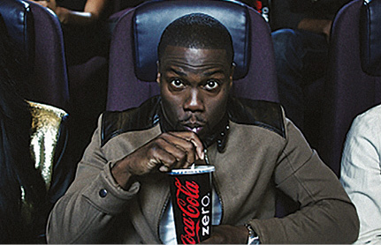 |  | 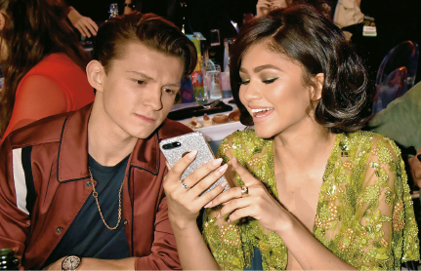
Kevin Hart loves ¹_____________________  at the cinema. |  | Zendaya likes ²_____________________  her friends.
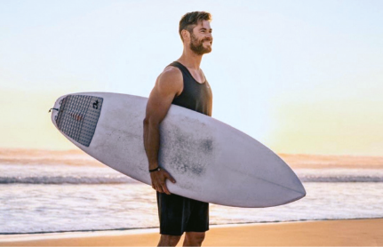 |  | 
Chris Hemsworth enjoys  ³_____________________ in his free time. |  | ⁴_____________________ is one of Margot  Robbie’s favourite hobbies.

