Countries and nationalities
Personal ID (Unit 1)
Apoio ao estudo
1
Name No.: ______ Class: ________ Date: _____/ _____/ _____

Para responderes às perguntas Where are you from? (De onde és?), How old are you? (Que idade tens?), When is your birthday? (Quando é o teu aniversário?), What nationality are you? (Qual é a tua nacionalidade?), … deves usar sempre o verbo to be (ex.: I am from Covilhã.; I am from Portugal.; I am 12 years old.; My birthday is on 5th March.; I am Portuguese.).
Para perguntar sobre os teus dados pessoais, deves prestar atenção às question words: who (quem), what (qual/quais), where (onde), when (quando), how (como), how old (que idade/quantos anos)…
Não te esqueças de que, em inglês, as nacionalidades se escrevem sempre com maiúsculas.
Bom estudo!
STUDY TIPS
A. Write the countries and the nationalities.
Country | Nationality |  | Country | Nationality
^{1.} | German |  | ^{6.} | Spanish
France | ^{2.} |  | The USA | ^{7.}
^{3.} | Irish |  | ^{8.} | Italian
Wales | ^{4.} |  | ^{9.} | Australian
Mexico | ^{5.} |  | England | ^{10.}
B. Match the questions with the answers. Write letters a-f.
1. What’s your name? a) They are German.

2. How old is Janine? b) It’s Nelson.

3. What nationality are Steve and Luke? c) It is on 13th January.

4. When is your dad’s birthday? d) My name’s Tessa.

5. Who is the new student? e) They are from Berlin.

6. Where are they from? f) She’s 25.



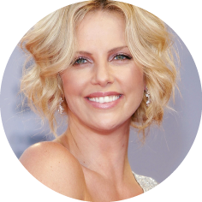
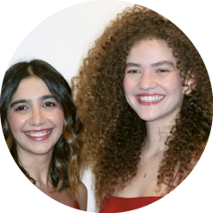
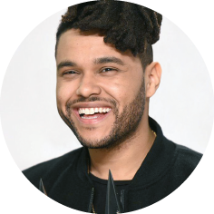
C. Fill in the gaps with the correct country or nationality.
Hi! I’m James McAvoy and I’m from Glasgow, in Scotland. I’m a 1______________ actor.
Charlize Theron is a South African actress. She was born in Benoni,
2_____________________.
Ana and Vitória are
3__________________ singers, from a small town in Brazil.
Do you know the
4__________________ singer The Weeknd?
His hometown is Toronto, in Canada.

