City features (Unit 4)
Apoio ao estudo
10
Name No.: ______ Class: ________ Date: _____/ _____/ _____

Nesta ficha de trabalho vais encontrar vocabulário relacionado com city features (características da cidade): roundabout – rotunda; traffic lights – semáforos; crossroads – cruzamento; tunnel – túnel; bridge – ponte…
Para mais facilmente memorizares este vocabulário, podes procurar um mapa de uma cidade e legendar os locais e as características da cidade com as palavras que aprendeste.
Bom estudo!
STUDY TIPS
A. Unscramble the letters and label the city features.
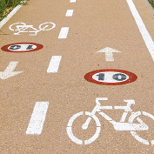 | 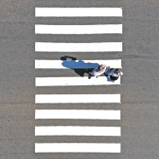 | 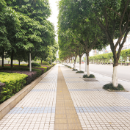 |  | 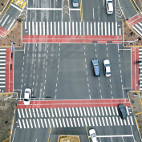
E Y C L C N L E A | E Z B A R  R S O I G N C S | T A N V P E E M | R C A F T F I  N I G S | S R O C D S R O S A
1. | 2. | 3. | 4. | 5.
B. Complete the sentences with the missing city features.
1. I live in a beautiful city with a big river, so every time we want to go to the other side we need to cross the ______________________.
b
2. Gina and Adam went to Edmonton, but they didn’t know the city, so they got lost and didn’t find the right ____________ _____________ to catch the downtown bus.
l
t
s
b
3. Be careful every time you cross the road. You must respect the ____________ _____________ and wait for the green one.
t
4. My cousin loves running, especially through that new ______________________ under the road.
5. Last weekend, Sarah saw a terrible accident. A lady started driving in circles around a ______________________ and couldn’t stop her car when another driver got in the way.
r
C. Match the sentences from exercise B with the pictures below. Write the numbers (1-5).
