Family members
Physical description (Unit 1)
Apoio ao estudo
2
Name No.: ______ Class: ________ Date: _____/ _____/ _____

Para descreveres alguém, precisas de utilizar vocabulário e adjetivos específicos.
Não te esqueças de que, em inglês, a ordem dos adjetivos é:
• adjetivo + nome (ex.: I have got red hair.);
• verbo to be + adjetivo (ex.: He is good-looking.).
Se usares mais do que um adjetivo para descrever o cabelo, por exemplo, a ordem deverá ser:
tamanho (1), o estilo (2) e a cor (3) e só depois o nome (ex.: My sister has got long (1) wavy (2) brown (3) hair.).
Nota: habitualmente, os adjetivos handsome (bonito) e good-looking (bem parecido) são utilizados para o masculino. Para o feminino, usamos pretty ou beautiful (bonita).
Bom estudo!
STUDY TIPS

A. Look at the family tree and complete the sentences with the correct family member.
Damien
Lisa
Gianna
Jeff
Jill
Charles
Nancy
Mark
Jenny
Jenny ’s family
My name’s Jenny and this is my family.
My 1__________________ is forty years old and his name is Jeff. Gianna is my 2__________________ and she’s thirty-nine years old. I haven’t got any brothers or sisters, so I’m an only child. I sometimes go to my 3__________________’ house (Damien and Lisa) and I play with my 4__________________ Nancy and her baby 5__________________ Mark.
Their 6__________________, Jill and Charles, are my 7_________________ and my 8_________________.

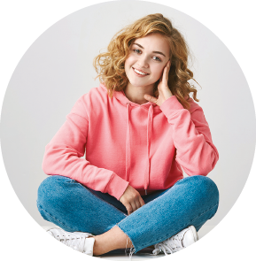

B. Look at the picture and circle the correct words to describe Nancy, Jenny’s cousin.
Nancy is a very 1 sad / happy girl. Her eyes are brown and she has got a 2 round / square face and 3 wavy brown / straight black hair.
She loves wearing casual clothes. In this picture, she is wearing a pink 4 blouse / sweater, her favourite 5 jeans / shorts and her white
6 boots / trainers, of course. Isn’t she 7 handsome / pretty?

