Daily routine
Telling the time (Unit 1)
Apoio ao estudo
3
Name No.: ______ Class: ________ Date: _____/ _____/ _____

Para descreveres a rotina diária em inglês, existem expressões que deverás usar, como por exemplo: wake up, get dressed, have a shower, do the homework, go to school, have football practice, brush the teeth, watch TV...
A descrição da rotina diária é, muitas vezes, acompanhada pela indicação das horas. Quando te referes à hora certa, deverás utilizar a expressão o’clock (ex.: at 7 o’clock); half significa “meia-hora” e a quarter “um quarto de hora”.
Em inglês, dizem-se primeiro os minutos, seguidos de past, até à meia-hora, e to depois da meia-hora. Só depois se dizem as horas. Ora repara: It’s twenty past eight. (São 8:20.); It’s ten to seven. (São 6:50.).
Se for antes do meio-dia, deves incluir a.m. e, se for depois do meio-dia, deves incluir p.m.
Meio-dia diz-se midday e meia-noite midnight.
Bom estudo!
STUDY TIPS
A. Write the time under the clocks.
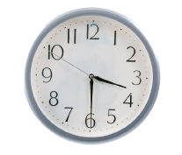 | 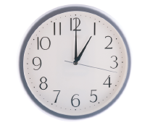 | 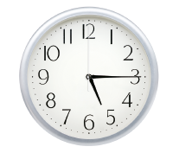 | 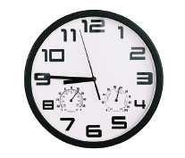
1. It’s | 2. | 3. | 4.

B. Find and circle six daily routine activities in the word snakes.
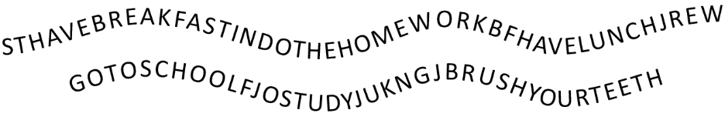
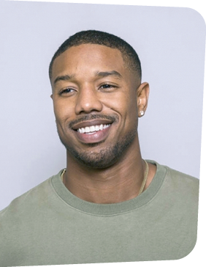
C. Complete the text with the correct daily routine activities. Pay attention to the pictures.

Michael B. Jordan is a very busy actor. He always 1__________________  at 6 a.m. and 2________________  to the gym. He works out for about one hour and then he 3______________________  and 4__________________ . Then he 5__________________  in the kitchen. He usually eats fruit and toast or pancakes and drinks orange juice. After a hard day at the studio, he goes back home at around 7 p.m. and 6_________________  . He loves preparing his own meals. He does the washing up and he 7________________  . Finally, he 8_______________ 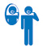 and 9__________________ a book. He 10__________________  at 11 p.m.

