Household chores (Unit 2)
Apoio ao estudo
4
Name No.: ______ Class: ________ Date: _____/ _____/ _____

Nesta ficha encontrarás vocabulário específico relacionado com as tarefas domésticas, que são também atividades de rotina diária.
Para estudares este vocabulário, poderás elaborar listas de palavras ou pesquisar imagens online de várias tarefas para as legendares e/ou descreveres.
Bom estudo!
STUDY TIPS
A. Match the household chores with the pictures. Write letters a-f.
1. do the ironing | 3. fold the laundry | 5. set the table
2. do the laundry | 4. take the rubbish out | 6. wash the car
  a) | 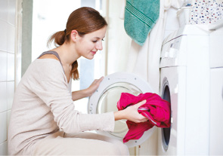  b) | 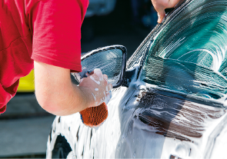  c)
  d) |   e) |   f)
B. Read the post-it notes and complete the sentences with the household chores from the box.







Dear Joe,
Don't forget to
1_______________
lunch and
2_______________ .
Love,
Mum
Hi, Matt!
Jim is coming at noon to
3_______________ .
There's money on
the kitchen table.
See you later,
Megan
Dear John,
Lunch is in the fridge.
Heat it in the microwave
and don't forget to
3_______________
after.
Love, Val
Hey!
Cleaning day! Please,
5_______________
and then
6_____________ it.
I'll be back at 1 p.m.
Sue
load the dishwasher | vacuum the floor | cook
do the washing up | cut the grass | mop

