Types of houses; Rooms and parts
of the house; Furniture (Unit 2)
Apoio ao estudo
5
Name No.: ______ Class: ________ Date: _____/ _____/ _____

Vais estudar alguns dos tipos de casa existentes em Inglaterra ou noutros países, divisões da casa e peças de mobiliário. Tenta memorizar as palavras escrevendo no teu caderno diário frases onde incluas este vocabulário (exs.: I live in a detached house. / My dream house is a tree house. / There are two bedrooms and one living room in my house. / I’ve got a bunk bed in my bedroom and there’s a big bookcase in front of it.).
Deves ainda rever as question words Where? e What (type of)? para perguntares “onde” e “em que tipo de casa” alguém habita; e How many? (quantos/as) para saberes o número de divisões.
Para descreveres o espaço ou as divisões deves utilizar os verbos there to be, to be e have got
(exs.: There’s a rug on the bathroom floor. / The house is big. / I have got a lovely bedroom.) e as prepositions of place (ex.: There are two plants on the table.).
Bom estudo!
STUDY TIPS
A. Look at the pictures and complete the sentences to label the types of houses. The first letter is given.
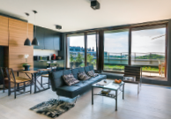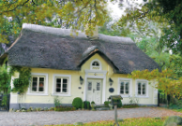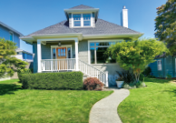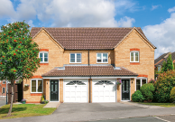
d
f
1
2
3
4
5

1. Look at Jane’s modern __________________.
c
2. Helena’s __________________ is in Ireland.
c
3. Tom loves his __________________.
4. Vince and Val live in a __________________ house.
d
s
5. Peter lives in a __________-_______________ house.

B. Find five parts/rooms of the house and five objects in the word search puzzle (→↑).
G | K | M | P | U | W | A | S | H | B | A | S | I | N
U | T | V | S | I | C | X | J | C | J | B | B | K | F
V | C | X | R | O | B | E | D | R | O | O | M | X | E
D | I | S | H | W | A | S | H | E | R | M | G | A | R
F | U | O | L | G | F | R | I | D | G | E | P | D | H
B | G | J | I | J | R | F | D | T | K | B | K | W | B
A | T | V | V | M | K | M | E | U | B | O | I | C | I
L | N | M | I | U | W | V | S | B | A | O | T | S | B
C | X | L | N | O | L | I | K | R | T | K | C | X | V
O | F | X | G | B | W | U | G | W | H | S | H | W | W
N | R | N | R | G | K | V | O | O | R | H | E | Q | H
Y | C | I | O | E | G | E | Z | L | O | E | N | I | A
K | K | W | O | N | Q | W | G | B | O | L | A | Y | Z
C | O | K | M | S | D | P | M | H | M | F | H | P | V
C. Put the words from exercise B in the correct column.
1. Parts/Rooms of the house | 2. Objects

