School facilities/rooms
School events (Unit 3)
Apoio ao estudo
7
Name No.: ______ Class: ________ Date: _____/ _____/ _____
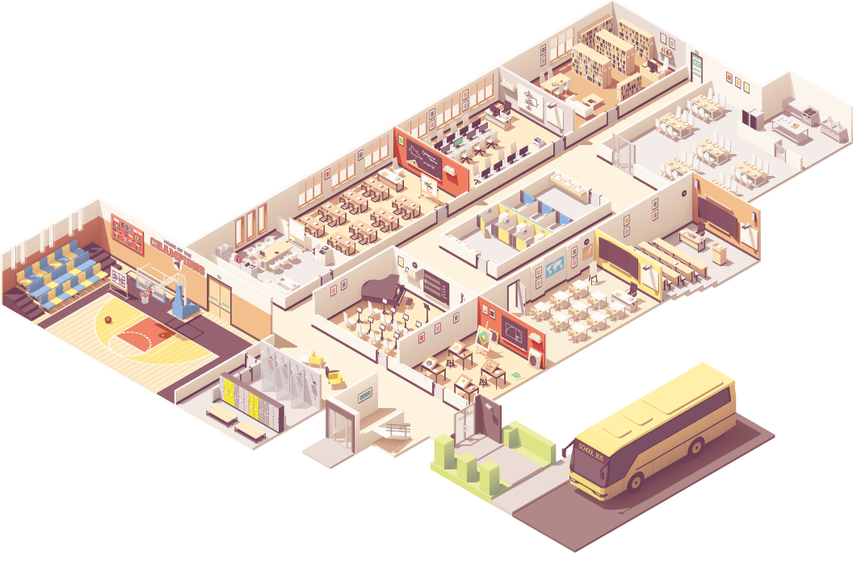

1
2
3
4
5
6
7
8
9
Para memorizares vocabulário relacionado com instalações/espaços e eventos escolares, podes fazer listas de palavras no teu caderno diário, tantas vezes quantas as que achares necessárias, ou criar um glossário/minidicionário global em português e em inglês (ou vice-versa). Podes ir acrescentando palavras novas, por categorias (espaços da escola, atividades escolares…), por exemplo.
Bom estudo!
STUDY TIPS
A. Look at the school map and match the facilities
with the words. Write the numbers 1-9.
a) gym

b) art room

c) classroom

d) toilets g) computer room

e) canteen h) library

f) music room i) changing room

B. Complete the calendar with the school events from the box. There are two extra expressions.
School MasterChef | Singing Contest | Chess Tournament |  | Gaming Tournament
Book Fair | Carnival Costume Contest |  | Sports Day | Science Fair


19th – 1__________________
16th – Welcome dance night
September
19th – 4________________________
14th – Valentine’s Day card contest
February
16th – Halloween party
5th – 2________________
October
21th – 5_______________
12th – School play
March
23th – I’m thankful for… day
11th – 3____________________
November
24th – 6_______________
17th – Talent show
May

