Shops (Unit 4)
Apoio ao estudo
9
Name No.: ______ Class: ________ Date: _____/ _____/ _____

Nesta ficha de trabalho vais encontrar algum vocabulário relacionado com os principais espaços comerciais e lojas.
Para mais facilmente memorizares este vocabulário, faz uma lista no teu caderno diário, associando-o a produtos que poderás comprar em cada um dos espaços (ex.: greengrocer’s – bananas, carrots…).
Bom estudo!
STUDY TIPS

A. Phoebe Dynevor went shopping, but the products weren’t in the right shops… She’s telling a friend about her shopping adventure. The mistakes are underlined. Write the correct words under the speech bubbles.
Hey, Claudia! I went shopping and I wanted to buy a dress for a party, so I went to the 1 greengrocer’s and found a fabulous one. As I needed shoes to wear with the dress, I went to the 2 pet shop, of course. Then, I decided to buy some food for my cat at the 3 bookshop and at the 4 baker’s I found a beautiful pair of trainers. It was love at first sight! Before going back home, I needed to look for a new mobile phone and I went to the 5 florist’s and saw a lovely one with lots of hearts and flowers on it, but I didn’t buy it. Maybe next time.

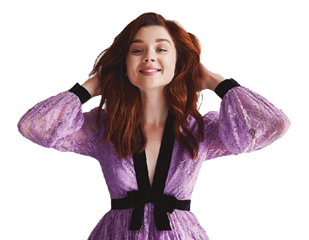
Phoebe
Dynevor
(actress)
Hi, Phoebe! Are you feeling OK? How did you buy and see all those products in those shops? Please, don’t tell me that you bought your favourite magazine at the 6 fishmonger’s, too…

1. | 2. | 3.
4. | 5. | 6.
Claudia
Jessie
(actress)

B. Label the pictures with five shops from the dialogue in exercise A.
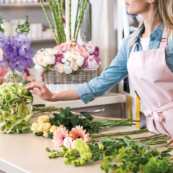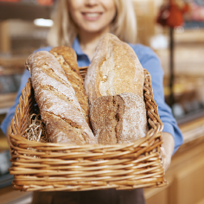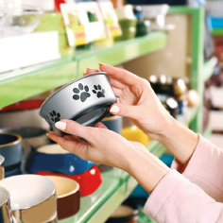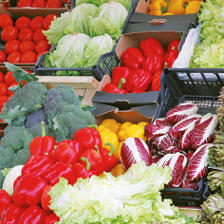
1
2
3
4
5
1. | 2. | 3. | 4. | 5.

