Physical description (Unit 1)
Worksheet
1A6
Name No.: ______ Class: ________ Date: _____/ _____/ _____
A. Look at the photos and read the text. Who is Colin’s favourite singer?
Tick (✓) the correct option.
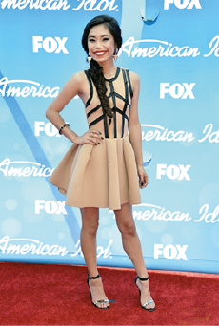 | 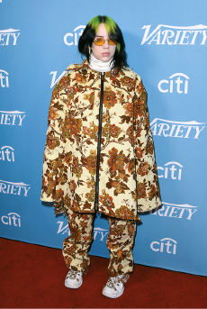 | 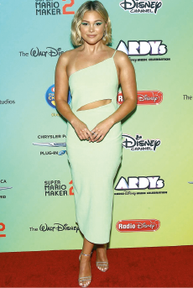 | 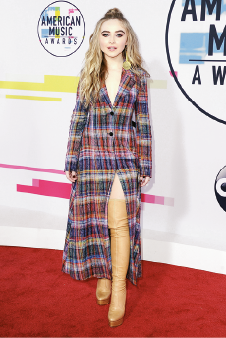
1. Jessica Sanchez | 2. Billie Eilish | 3. Olivia Holt | 4. Sabrina Carpenter
She is quite beautiful and young. She is tall and she isn’t fat – she’s slim. She hasn’t got dark hair.
Her hair is blonde and wavy, but it isn’t long – it’s short. Her skin isn’t dark – it’s fair.
B. List the words in bold from the text in exercise A in the correct columns.
1. Height | 2. Build/Weight | 3. Age | 4. Hair | 5. Skin | 6. General  appearance
C. Which category from the table in exercise B do these words belong to? Write 1-6.
a) curly | c) freckles | e) medium height
b) handsome | d) plump | f) old
D. Look at Billie Eilish’s photo in exercise A and complete her description.
Billie is 1__________________ (weight) and slim. Her face is 2__________________.
She has got big eyes and 3__________________ skin.
She has got 4__________________ 5__________________ 6__________________ hair.
E. Think about your favourite singer and complete his/her description.
______________________ (your favourite singer’s name) is (height) and
________________ (weight). His/ Her face is ________________. He/She has got
________________ eyes and ________________ skin. He/She has got
_____________________________________ hair.

