Physical description (Unit 1)
Worksheet
1B6
Name No.: ______ Class: ________ Date: _____/ _____/ _____
A. Look at the photos and read the text. Who is Colin’s favourite singer?
Tick (✓) the correct option.
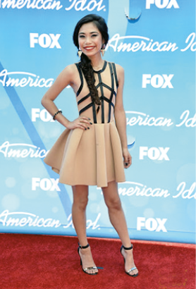 |  | 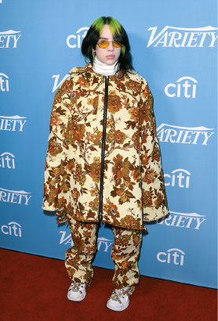 |  | 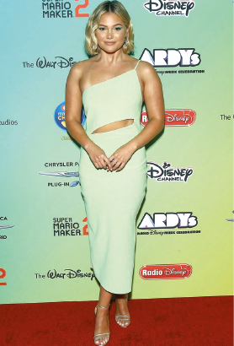
1. Jessica Sanchez |  | 2. Billie Eilish |  | 3. Olivia Holt
She is quite beautiful and young. She is tall and she isn’t fat – she’s slim. She hasn’t got dark hair.
Her hair is blonde and wavy, but it isn’t long – it’s short. Her skin isn’t dark – it’s fair.
B. Complete the table with the words from the box.
blonde | young | tall | fat | pale | slim | wavy | beautiful

1. Height | 2. Build/Weight | 3. Age | 4. Hair | 5. Skin | 6. General  appearance
C. Which category from the table in exercise B do these words belong to? Write 1-6.
a) curly | c) freckles | e) medium height
b) handsome | d) plump | f) old

D. Look at Billie Eilish’s photo in exercise A and circle the correct option to complete her description.
Billie is ¹ medium height / small and slim. Her face is ² oval / short.
She has got big green eyes and ³ dark / fair skin.
She has got ⁴ long / short ⁵ straight / curly ⁶ dark / light hair.

