Physical description (Unit 1)
Worksheet
1C6
Name No.: ______ Class: ________ Date: _____/ _____/ _____
A. Look at the photos. Read the descriptions and find out who is who. Write their names.
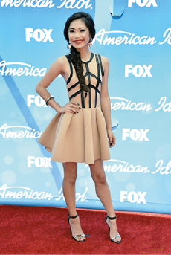 | She is beautiful and young. She is tall and  slim. Her hair is blonde and wavy. Her  eyes are brown and her skin is light.  ____________________  1  She is medium height and slim. Her hair  is long and dark. Her eyes are dark too.  ____________________  2 | 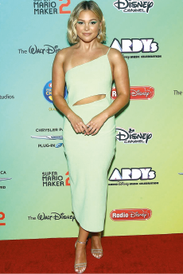
Jessica Sanchez |  | Olivia Holt
B. Look at Billie Eilish’s photo and label it with the expressions from the box.
small mouth | green eyes | oval face | black hair | pale skin

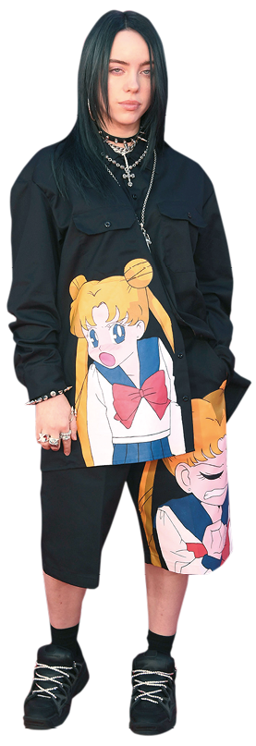

2. _______________________

3. _______________________
1. _______________________
4. _______________________

5. _______________________

