Summer activities (Unit 5)
Worksheet
10A6
Name No.: ______ Class: ________ Date: _____/ _____/ _____

A. Which word or phrase in each group is different? Circle it.
1. camping – dancing – having a picnic – going to the swimming pool
2. sunbathing – going to the beach – swimming – singing
3. surfing – swimming – eating ice creams – snorkelling
4. going to a theme park – canoeing – fishing – snorkelling
5. sailing – taking photos – going to a theme park – eating ice creams
B. Look at these doodles and use the words/expressions from exercise A to find out which activities Ricky is going to do next summer. Complete the text with those activities.
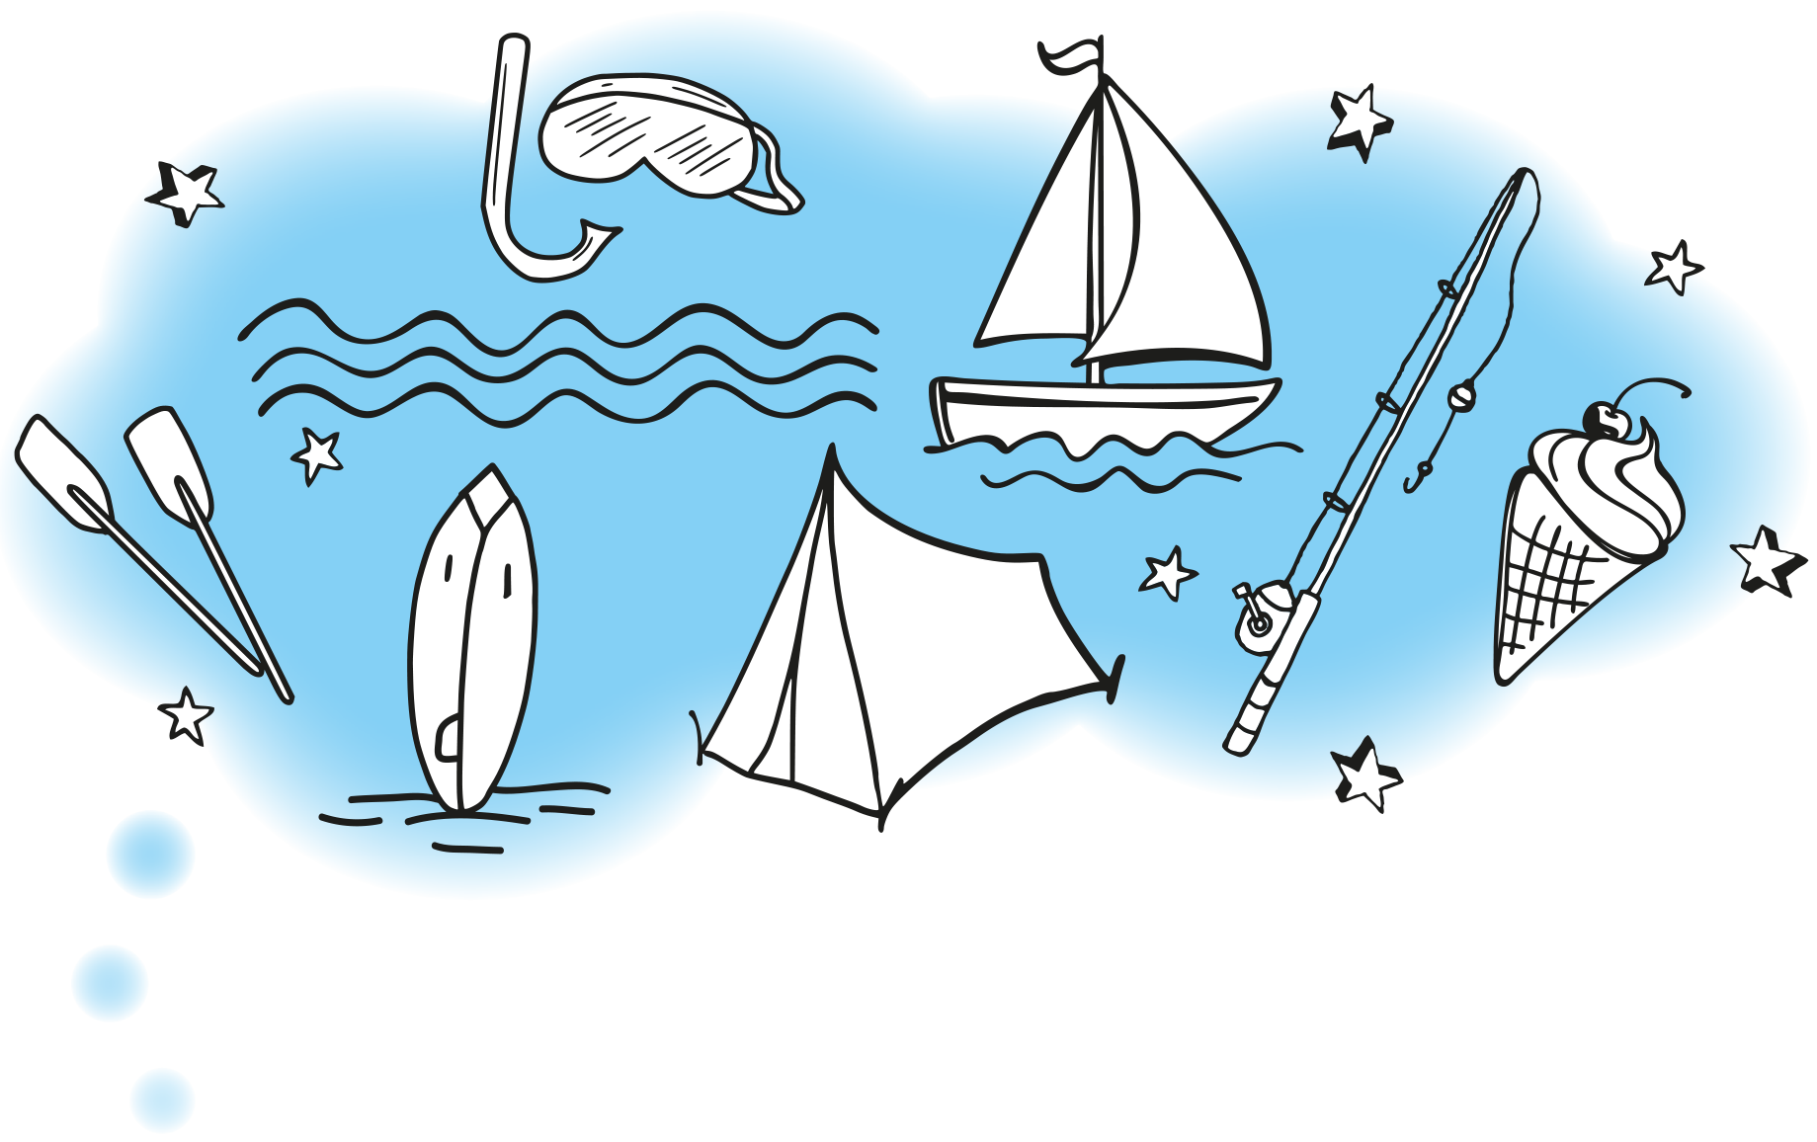
going to the beach
I’m •___________________ every day in the morning. That’s
where I’m going to meet my friends: in that sunny beach! We’re
1___________________ the big waves with our new surfboards
early in the morning. After that we need to find our lunch,
so we’re 2___________________ to try to find some fresh fish!
We’re 3___________________ in the sea the rest of the time with
our goggles to admire the undersea creatures! In the afternoon,
we’re 4________________. Vanilla and strawberry are our favourites!
If we have time, we’re definitely 5__________________ with
Jonathan’s canoe or we’re 6__________________ in his little boat!
We still want to try 7__________________. We avoid it because
our friend Tina hates sleeping in the outdoors, but this year she is
going to try it!

