Summer activities (Unit 5)
Worksheet
10B6
Name No.: ______ Class: ________ Date: _____/ _____/ _____

A. Which word or phrase in each group is different? Circle it.
1. camping – dancing – going to the swimming pool
2. sunbathing – going to the beach – singing
3. surfing – swimming – eating ice creams
4. going to a theme park – fishing – snorkelling
5. sailing – taking photos – eating ice creams
B. Look at these doodles and unscramble the words/expressions in the text to find out which activities Ricky is going to do next summer. Start each word with the coloured letters.
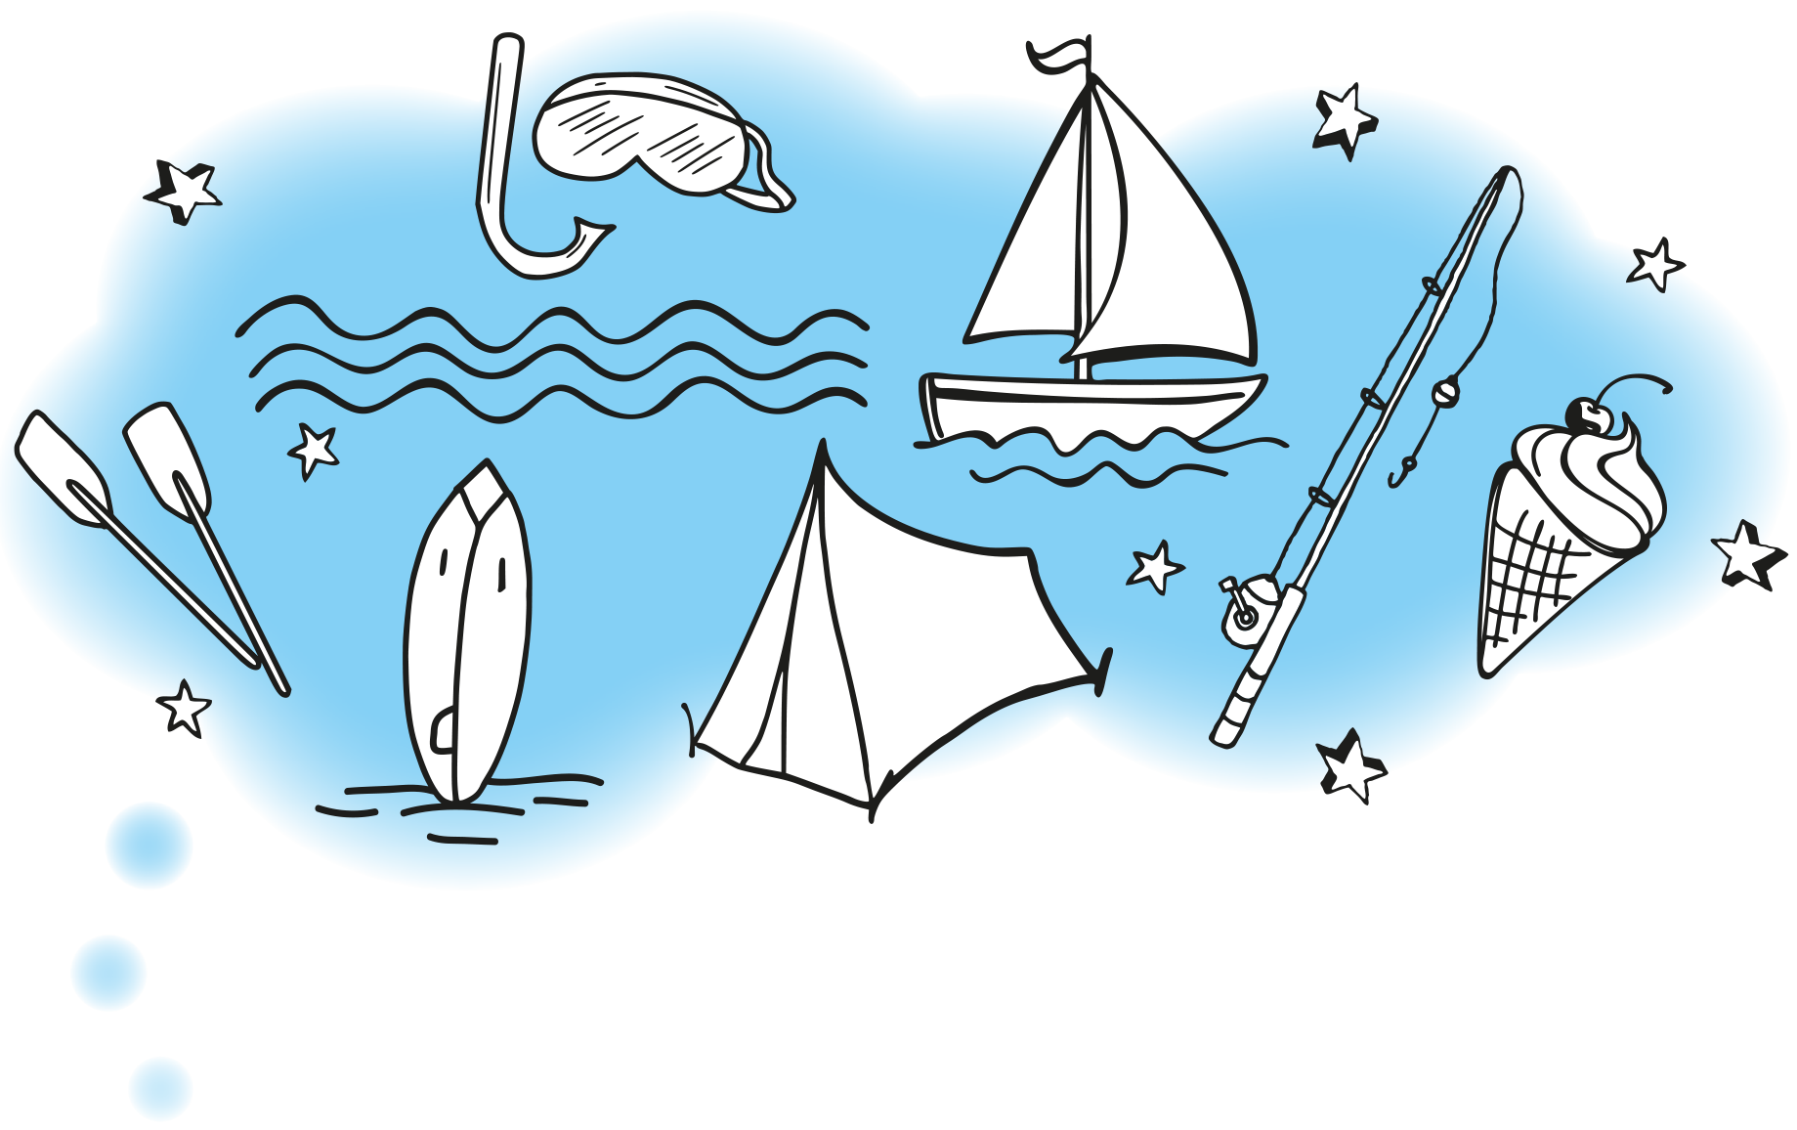
I’m going to the beach every day in the morning. That’s where I’m
going to meet my friends: in that sunny beach! We’re going ¹ fsingur
the big waves with our new surfboards early in the morning. After
that we need to find our lunch, so we’re going ² isfhngi to try to
find some fresh fish! We’ree going ³ nkllsoreing in the sea the rest
of the time with our goggles to admire the undersea creatures!
In the afternoon, we’re going to ⁴ tae cei recams. Vanilla and
strawberry are our favourites! If we have time, we’re definitely
canoeing with Jonathan’s canoe or we’re going ⁵ ilsangi in his little
boat! We still want to try going ⁶ mpcaing. We avoid it because
our friend Tina hates sleeping in the outdoors, but this year she is
going to try it!

1. | 4.
2. | 5.
3. | 6.

