Summer activities (Unit 5)
Worksheet
10C6
Name No.: ______ Class: ________ Date: _____/ _____/ _____
A. Look at these doodles and unscramble the words in the text to find out which activities Ricky is going to do next summer. Start each word with the coloured letters.
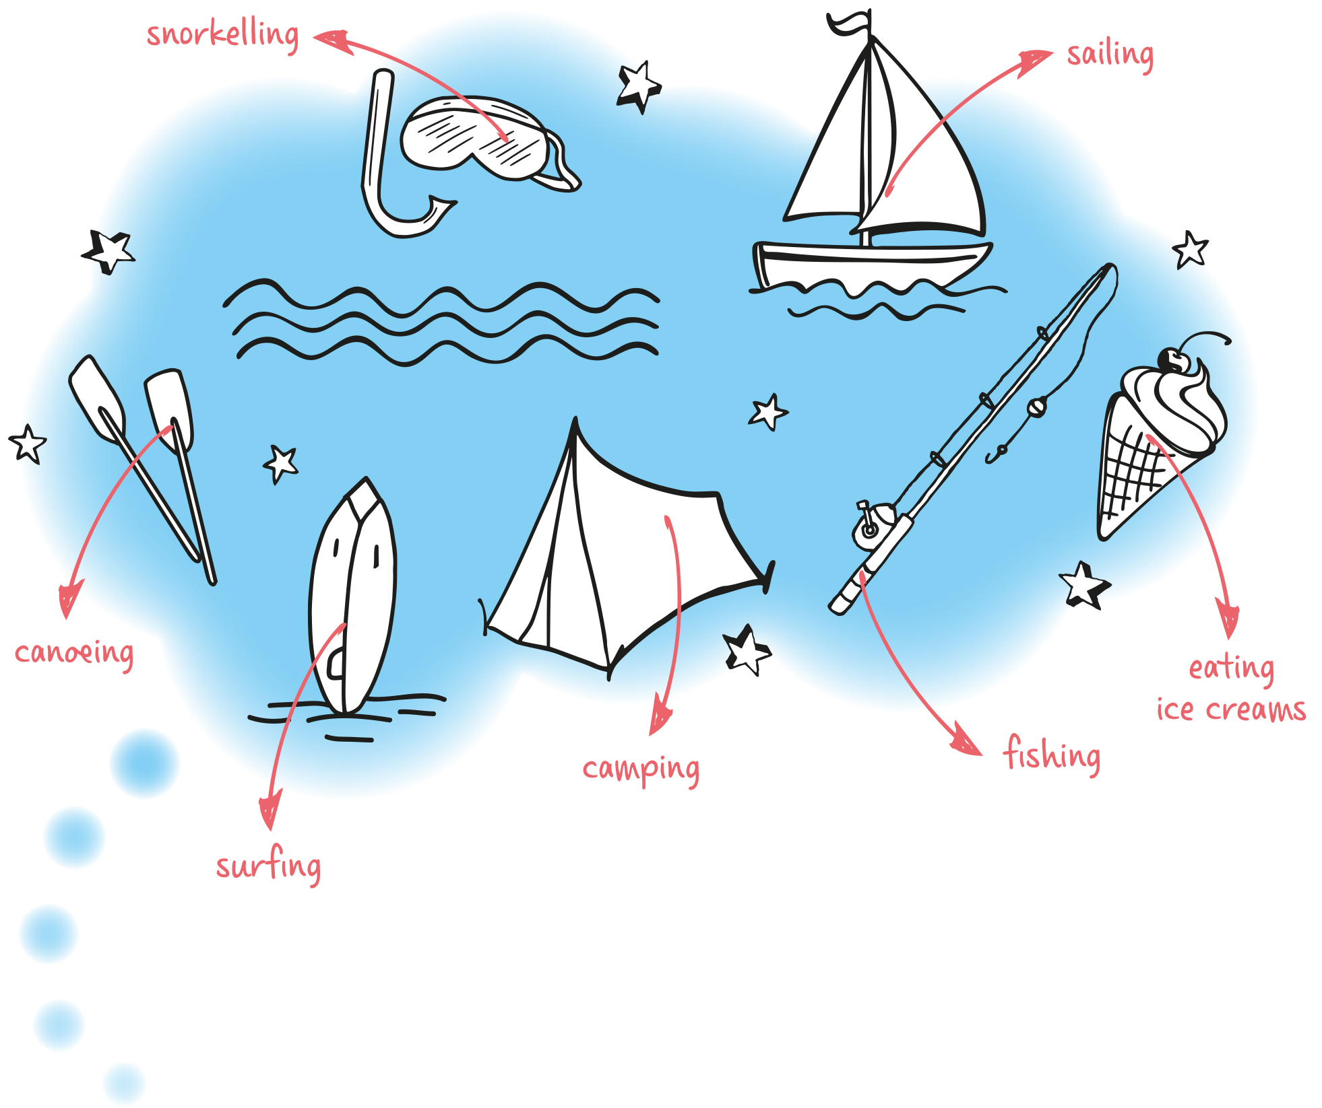
I’m going to the beach every day in the morning. That’s where
I’m going to meet my friends: in that sunny beach! We’re going
¹ fsingur – ___________________ the big waves with our news
surfboards early in the morning. After that we need to find our
lunch, so we’re going ² isfhngi – ___________________ to try to find
some fresh fish! We’re going ³ nkllsoreing – ___________________
in the sea the rest of the time with our goggles to admire
the undersea creatures! In the afternoon, we’re going to
⁵ tae cei recams– ___________________. Vanilla and strawberry
are our favourites! If we have time, we’re definitely canoeing
with Jonathan’s canoe or we’re going
⁶ ilsangi – ___________________ in his little boat! We still want
to try going ⁷ mpcaing – ___________________. We avoid it
because our friend Tina hates sleeping in the outdoors, but this
year she is going to try it!

