Daily routine activities (Unit 1)
Worksheet
2A6
Name No.: ______ Class: ________ Date: _____/ _____/ _____
A. Complete the expressions for routine activities.
1. _____________ your teeth | 4. _____________ dressed | 7. _____________ lunch
2. _____________ breakfast | 5. _____________ to school | 8. _____________ your homework
3. _____________ a shower | 6. _____________ classes | 9. _____________ to sleep
B. Look at the pictures and complete the sentences. Use expressions from exercise A and the correct times.
  Hi, I’m Neil! Here’s some of  my daily routine activities! | 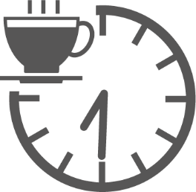 | 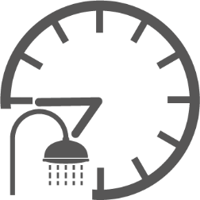 | 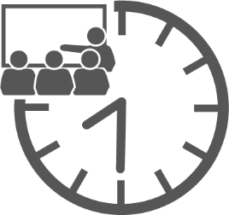  3
 | 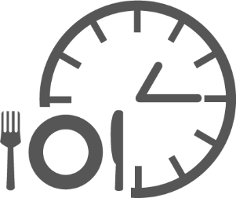  1 | 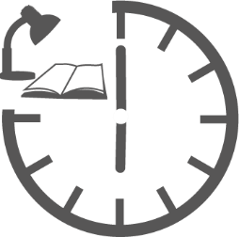  6  5  4  2 | 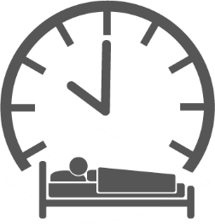
1. I _________________ at _________________. 4. I _________________ at _________________.
half past seven
2. I _________________ at _________________. 5. I _________________ at _________________.
3. I _________________ at _________________. 6. I _________________ at _________________.
C. Complete the questions with the words from the box. Then answer shortly about YOU.
wake up | foot |  | home |  | shower |  | sleep
cereal |  | lunch |  | homework |  | watch

1. “What time do you _________________?” “At __________________________________.”
2. “Do you have _________________ for breakfast? ” “______________, ____________________.”
3. “Do you leave _________________ at eight o’clock? “______________, ____________________.”
4. “Do you go to school on _________________?” “______________, ____________________.”
5. “Do you usually have _________________ at school?” “______________, ____________________.”
6. “Do you do your ________________ in your bedroom?” “_____________, ___________________.”
7. “Do you _________________ TV after dinner?” “______________, ____________________.”
8. “Do you have a ________________ before going to bed?” “____________, ___________________.”
9. “Do you go to _________________ late at night?” “______________, ____________________.”

