Daily routine activities (Unit 1)
Worksheet
2B6
Name No.: ______ Class: ________ Date: _____/ _____/ _____

A. Circle the correct verb to complete the phrases for routine activities.
1. comb / brush your teeth | 4. get / go dressed | 7. have / go lunch
2. drink / have breakfast | 5. go / catch to school | 8. have / do homework
3. send / have a shower | 6. have / do classes | 9. go / have to sleep
B. Look at the pictures and complete the sentences. Use expressions from exercise A and circle the correct times.
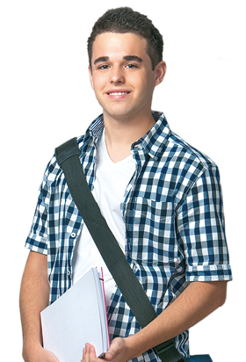  Hi, I’m Neil! Here’s some of  my daily routine activities! | 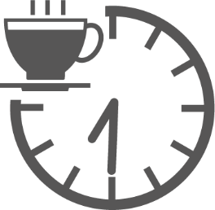 | 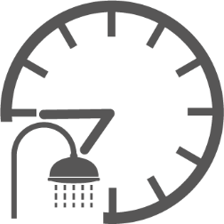 | 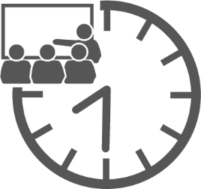  2
 | 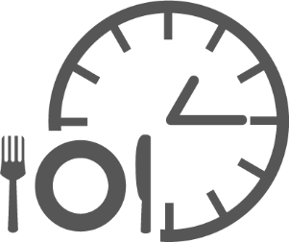  • | 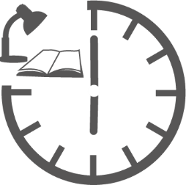  5  4  3  1 | 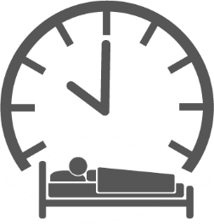
• I ____________________ at half past seven / half past eight.
have breakfast
1. I ____________________ at a quarter to eight / a quarter past eight.
2. I ____________________ at half past eight / a quarter past eight.
3. I ____________________ at quarter to one / quarter past one.
4. I ____________________ at six o’clock / five o’clock.
5. I ____________________ to sleep at half past nine / ten o'clock.
C. Complete the questions with the words from the box.
wake up
wake up | foot | home | sleep | cereal | lunch | watch

• Do you ____________________ early?
1. Do you have ____________________ for breakfast?
2. Do you leave ____________________ at eight o’clock?
3. Do you go to school on ____________________?
4. Do you usually have ____________________ at school?
5. Do you ____________________ TV after dinner?
6. Do you go to ____________________ late at night?

