Daily routine activities (Unit 1)
Worksheet
2C6
Name No.: ______ Class: ________ Date: _____/ _____/ _____

A. Look at the pictures and circle the correct daily routine activity and time to complete the sentences.

Hi, I’m Neil! Here’s  some of my daily  routine activities! |   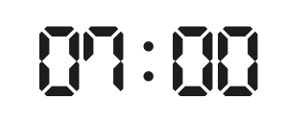  • |   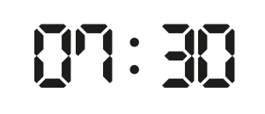  1 | 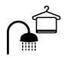  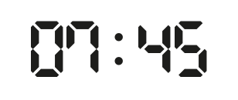  2
Hi, I’m Neil! Here’s  some of my daily  routine activities! |   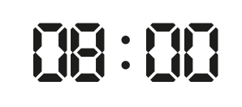  3 |   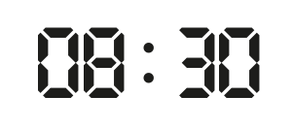  4 |   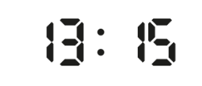  5
Hi, I’m Neil! Here’s  some of my daily  routine activities! |   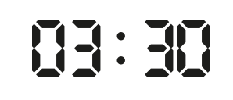  6 |   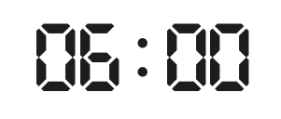  7 | 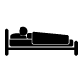  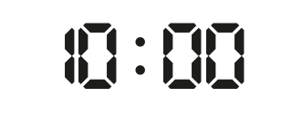  8

• I wake up / go to sleep at seven o’clock / ten past seven.
1. I have breakfast / have a shower at half past seven / a quarter past seven.
2. I have breakfast / have a shower at a quarter to eight / a quarter past eight.
3. I go to school / go home at seven o’clock / eight o’clock.
4. I have classes / finish classes at half past eight / half past nine.
5. I have lunch / have dinner at half past twelve / a quarter past one.
6. I go home / go to school at half past four / half past three.
7. I do my homework / watch TV at twenty past six / six o’clock.
8. I go to sleep / read a book at nine o'clock / ten o'clock.

