Household chores and types of houses (Unit 2)
Worksheet
3A6
Name No.: ______ Class: ________ Date: _____/ _____/ _____
A. Cheryl has lots of energy! Match the two parts of the pictures and write the household chores she does to help at home.
  A |   B | 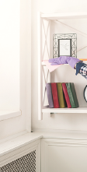  C |   D |   E | 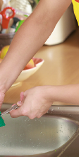  F |   G |   H
  I | 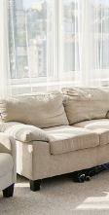  J |   K |   L |   M |   N |   O | 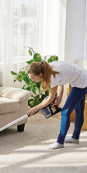  P
• A + _____ = ______________ 3. D + _____ = ______________ 6. K + _____ = ______________
make the bed
E
1. B + _____ = ______________ 4. I + _____ = ______________ 7. L + _____ = ______________
2. C + _____ = ______________ 5. J + _____ = ______________
B. Are you a busy bee or a couch potato? Which chores from exercise A do you usually do?

C. Read the text and complete it with the missing types of houses. The first letter is given.
the world’s most
EXTRAORDINARY
HOMES
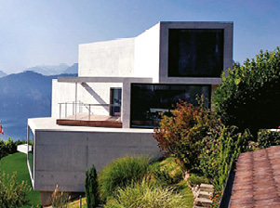 | 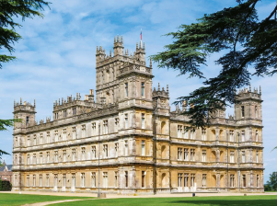  Downton  Abbey set | 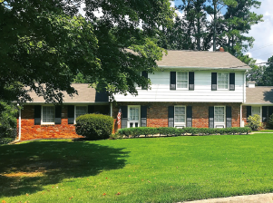  Wheeler house  (Stranger things)
The Netflix show The World’s Most Extraordinary Homes presents different types of houses that are able to leave you more surprised than ever. From a 1__________________ with more than 25 bedrooms and three swimming pools to a luxurious 2__________________ in the countryside, you won’t believe your eyes. You will see a 3__________________ on the 145th floor of a skyscraper and a 4__________________ __________________ that is often used as a film set, such as the Wheeler House, from the series Stranger things. Check out the 5__________________ similar to the one
from the series Downton Abbey or even a 6__________________ where the farm animals join you for breakfast!! Finally, get ready to get to know the 7__________________ – __________________ house of your dreams. There you’ll see two houses sharing a wall made of glass… isn’t that amazing?
d
S
f
c
h
d
f
c
m

