Household chores and types of houses (Unit 2)
Worksheet
3B6
Name No.: ______ Class: ________ Date: _____/ _____/ _____

A. Cheryl has lots of energy! Circle the correct household chore to label her activities.
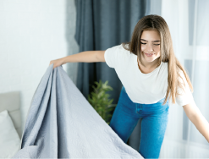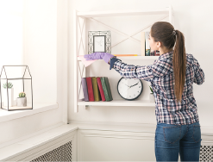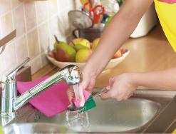
•
1
2
3
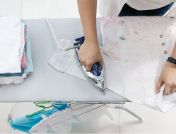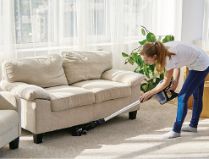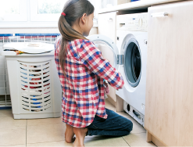
4
5
6
7
• make the bed / clear the table | 4. do the ironing / vacuum the floor
1. set the table / dust the furniture | 5. take the rubbish out / vacuum the floor
2. do the washing-up / dust the furniture | 6. do the laundry / do the ironing
3. do the laundry / do the washing-up | 7. do the laundry / take the rubbish out
B. Read the text and unscramble the types of houses to complete it. Start with the coloured letter.
the world’s most
EXTRAORDINARY
HOMES
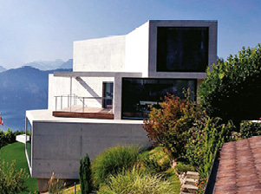 | 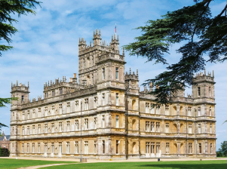  Downton  Abbey set | 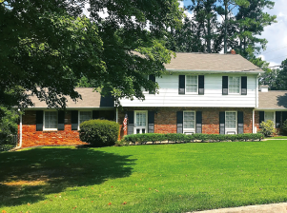  Wheeler house  (Stranger things)
The Netflix show The World’s Most Extraordinary Homes presents different types of houses that
are able to leave you more surprised than ever. From a • namison – __________________ with more than 25 bedrooms and three swimming pools to a luxurious ¹ aetogtc – __________________ in the countryside, you won’t believe your eyes. You will see a ² aftl – ________________ on the 145th floor of a skyscraper and a ³ ehetadcd – _______________ house that is often used as a film set, such
as the Wheeler House, from the series Stranger things. Check the ⁴ scaetl – __________________ similar to the one from the series Downton Abbey or even a ⁵ ouhsarfme – __________________ where the farm animals join you for breakfast!! Finally, get ready to get to know the ⁶ iems-ehetadcd _____________ – __________________ house of your dreams. There you’ll see two houses sharing a wall made of glass… isn’t that amazing?
mansion

