Household chores and types of houses (Unit 2)
Worksheet
3C6
Name No.: ______ Class: ________ Date: _____/ _____/ _____
A. Complete Cheryl’s household chores with the missing vowels (a, e, i, o, u).
 |  | 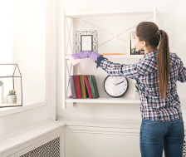 | 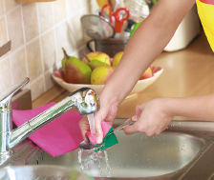
• m __ k __  t h __ b __ d  e  e  e  a | 1. s __ t  t h __ t __ b l __ | 2. d __ s t t h __  f __ r n __ t __ r __ | 3. d __ t h __  w __ s h __ n g - __ p
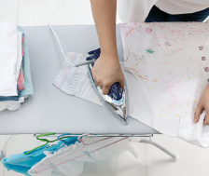 | 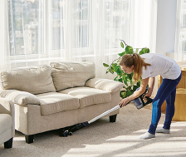 | 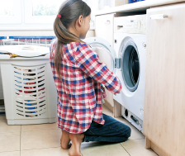 | 
4. d __ t h __  __ r __ n __ n g | 5. v __ c __ __ m  t h __ f l __ __ r | 6. d __ t h __  l __ __ n d r y | 7. t __ k __ t h __  r __ b b __ s h __ __ t
B. Match the pictures with the corresponding type of house.
a) mansion
b) castle
c) cottage
d) flat

e) semi-detached house
f) detached house
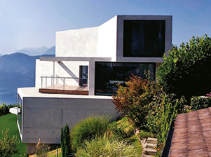  1 | 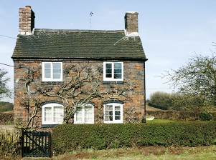  2 | 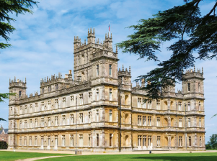  3
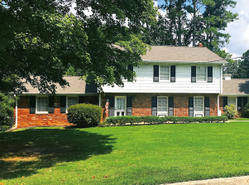  4) | 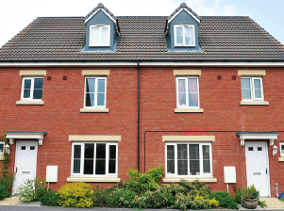  5 | 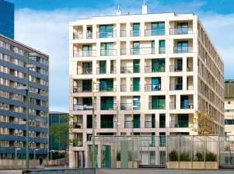  6

C. Circle the one that corresponds to the type of house you live in.

