Rooms, parts of the house and furniture (Unit 2)
Worksheet
4A6
Name No.: ______ Class: ________ Date: _____/ _____/ _____
A. Read the clues. Guess which rooms these The Umbrella Academy’s characters are talking about.
I love cooking, so it’s
where I try my dishes!
There are
flowers
here!
This is where I watch
TV sitting on my sofa.








Klaus
Diego
Allison
Luther
Vanya
Five
It’s where
I usually sleep!
This is where my
mother works!
It’s just below the
roof of the house.
• Vanya  bedroom | 2. Allison | 4. Diego
1. Five | 3. Luther | 5. Klaus
B. Label the items in these rooms from the series The Umbrella Academy.
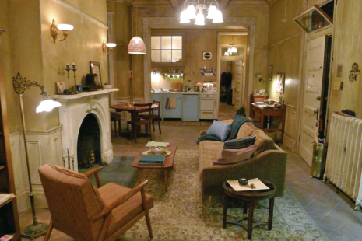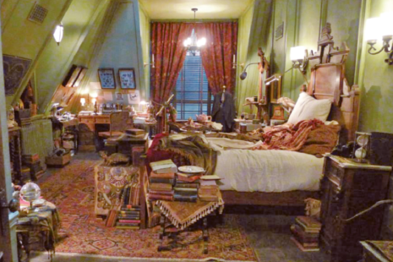
1
2
3
4
5
6
7
8
9
10
11
12
1. | 4. | 7. | 10.
2. | 5. | 8. | 11.
3. | 6. | 9. | 12.

