Rooms, parts of the house and furniture (Unit 2)
Worksheet
4B6
Name No.: ______ Class: ________ Date: _____/ _____/ _____

A. Read the clues. Guess which rooms these The Umbrella Academy’s characters are talking about.
Circle the correct option.
I love cooking, so it’s
where I try my dishes!
There are
flowers
here!
This is where I watch
TV sitting on my sofa.








Klaus
Diego
Allison
Five
Vanya
Luther
It’s where
I usually sleep!
This is where my
mother works!
It’s just below the
roof of the house.
• Vanya – bedroom / garden | 2. Allison – dining room / garden | 4. Diego – toilet / living room
1. Five – kitchen / study | 3. Luther – bathroom / kitchen | 5. Klaus – attic / garden
B. Label the items in these rooms from the series The Umbrella Academy. The first and the last letters
are given.
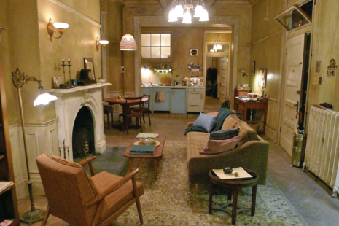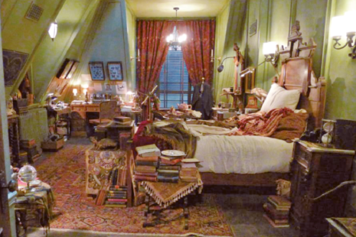
b d
d k
a r
f e
1
2
3
4
5
6
7
8
9
10
11
12
1.  l p | 4.  s a  t e | 7.  c s | 10.  b e t e  r g
2. | 5.  c e t e | 8.  p s | 11.
3. | 6. _______ | 9. | 12. _______

