Rooms, parts of the house and furniture (Unit 2)
Worksheet
4C6
Name No.: ______ Class: ________ Date: _____/ _____/ _____

A. Read the clues and guess which are these The Umbrella Academy characters’ favourite rooms.
Circle the correct option. There is one example.








Klaus
Diego
Allison
Five
Vanya
Luther
• Vanya likes to sleep:  bedroom / garden | 2. Allison loves picking flowers:  dining room / garden | 4. Diego watches TV every day:  toilet / living room
1. Five’s mother works a  lot: kitchen / study | 3. Luther cooks well:  bathroom / kitchen | 5. Klaus keeps his things  stored: dining room / attic
B. Match the pictures from rooms you see in the series The Umbrella Academy with the words below.
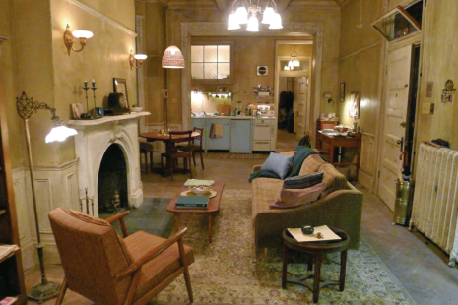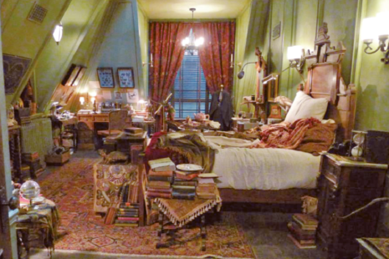
1
2
3
4
5
6
7
8
9
10
11
12
a) fireplace | d) lamp | g) curtains | j) rug
b) coffee table | e) sofa | h) bed | k) pillows
c) armchair | f) table | i) bedside table | l) desk

