School subjects and after-school clubs (Unit 3)
Worksheet
5A6
Name No.: ______ Class: ________ Date: _____/ _____/ _____
A. Complete the crosswords with school subjects.
1. H₂O
2. Guitar, piano, flute…
3. Buenos días!
4. Bonjour!
5. Ancient Greece…
6. 12585 -198 x 10…
7. “Chess” means “xadrez”
8. Lisbon, Madrid, Paris, London…
 |  |  |  |  |  |  |  |  |  |  |  |  |  |  |  |  |  | 
 |  |  |  |  |  | M |  |  |  |  | F |  |  |  |  | E |  | G
 |  |  |  |  |  |  |  |  | S
 |  |  |  |  |  |  |  |  |  |  |  |  |  | 
 | P |  |  |  |  |  |  |  |  |  |  |  |  | M
 |  |  |  |  |  |  |  |  |  |  |  | H
B. Look at the pictures and tick (✓) the correct option. Then label the pictures with the names of the correct after-school clubs.
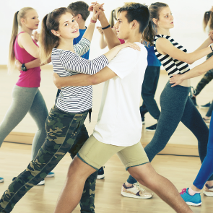 |  | 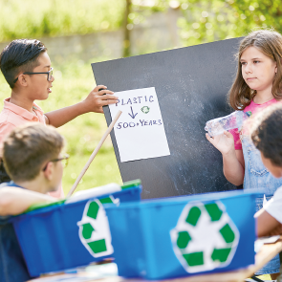
a) I learn dance routines.  b) I play chess. | a) I play video games.  b) I love watching films. | a) I organise campaigns.  b) I learn how to sing.
1. Club | 2. Club | 3. Club
 |  | 
a) I take amazing photos.  b) I send text messages. | a) I make experiments.  b) I study history. | a) I play Minecraft.  b) I play team games.
4. Club | 5. Club | 6. Club

