School subjects and after-school clubs (Unit 3)
Worksheet
5B6
Name No.: ______ Class: ________ Date: _____/ _____/ _____
A. Complete the crosswords with school subjects. Choose from the box.
1. H₂O
2. Guitar, piano, flute…
3. Buenos días!
4. Bonjour!
5. Ancient Greece…
6. 12585 -198 x 10…
7. “Chess” means “xadrez”
8. Lisbon, Madrid, Paris, London…
maths | English | geography | French | history | Spanish | physics and chemistry | music

 |  |  |  |  |  |  |  |  |  |  |  |  |  |  |  |  |  | 
 |  |  |  |  |  | M |  |  |  |  | F |  |  |  |  | E |  | G
 |  |  |  |  |  |  |  |  | S
 |  |  |  |  |  |  |  |  |  |  |  |  |  | 
 | P |  |  |  |  |  |  |  |  |  |  |  |  | M
 |  |  |  |  |  |  |  |  |  |  |  | H
B. Label the pictures with after-school clubs. The first letter is given.
S
S
P
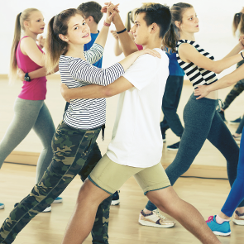 |  | 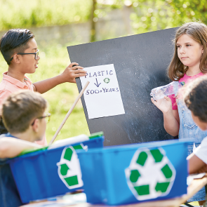
1. Club | 2. Club | 3. Club
  D |   F |   N
4. Club | 5. Club | 6. Club
C. Do you go to an after-school club? If so, which one?
Yes, I do. I go to / No, I don't.

