School subjects and after-school clubs (Unit 3)
Worksheet
5C6
Name No.: ______ Class: ________ Date: _____/ _____/ _____


A. Find seven school subjects in the wordsearch (↑→).
1
2
1. Guitar, piano, flute… | J | X | A | D | J | B | A | F | L | B | Q | M | E | N | I
2. Buenos días! | S | M | U | S | I | C | C | W | N | V | W | G | Y | E | C
3. Bonjour! | J | E | X | J | H | E | G | X | U | Y | R | D | R | B | S
4. Ancient Greece… | J | D | O | H | H | J | D | I | K | N | X | Q | G | E | K
5. 12585 -198 x 10… | E | N | G | L | I | S | H | P | N | Y | M | A | T | H | S
6. “Chess” means “xadrez” | G | G | C | Z | N | S | W | Z | V | F | N | P | R | K | M
7. Lisbon, Madrid, Paris, London… | W | E | S | Y | L | C | N | T | I | A | O | R | J | F | F
 | H | O | P | B | N | M | T | E | M | O | B | H | Q | R | C
 | I | G | A | C | V | A | Q | D | F | V | B | X | N | E | H
 | S | R | N | A | N | Z | S | S | G | E | S | M | U | N | H
 | T | A | I | L | C | D | P | B | R | A | X | X | D | C | N
 | O | P | S | N | P | E | Q | A | M | C | H | F | N | H | Z
 | R | H | H | V | L | J | I | N | X | U | F | E | L | N | O
        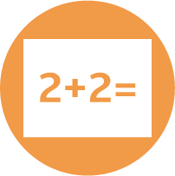  4  6  7  3  5 | Y | Y | S | B | I | X | A | E | B | T | E | Y | H | H | I
 | L | Z | D | R | H | R | O | Q | P | A | C | Z | A | X | B

B. Look at the pictures and circle the correct after-school club.
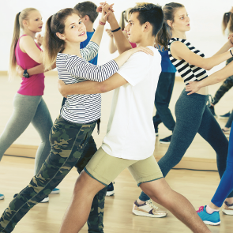 |  | 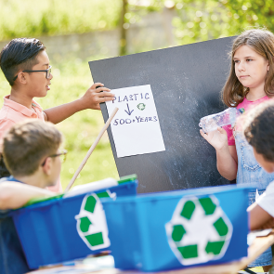
1. Dance Club / Computer Club | 2. Film Club / Maths Club | 3. Music Club / Nature Club
 |  | 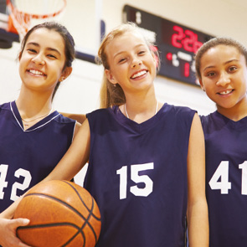
4. Book Club /  Photography Club | 5. Science Club / Chess Club | 6. Minecraft Club / Sports Club

