School facilities and events (Unit 3)
Worksheet
6A6
Name No.: ______ Class: ________ Date: _____/ _____/ _____
A. Look at the pictures of school facilities. Read the clues and cross out the pictures to find out where the impostor is. Write the correct school facility to complete the sentence at the end.
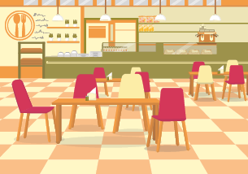 | 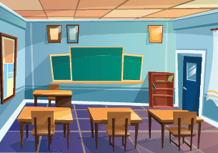 | 
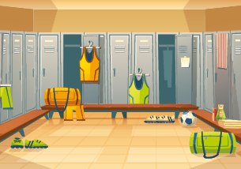 |  | 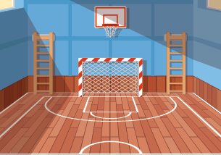
He isn’t in the classroom.
He isn’t in the sports field.
He isn’t in the changing room.
He isn’t in the headmaster’s office.
He isn’t in the gym.
So the impostor  is in the ____________________________________. Tricky hungry boy!!!
B. Look at the pictures and read the sentences. Which school event are these characters from the game Among Us going to participate in? Complete the name of the event with the missing letters.

6
5
4
3
2
1
1. We go to a V __ L __ N T I __ E’ __ Day party! Love is in the air!
2. I’m wearing a Harry Potter costume for the __ A __ N I __ A __ party.
3. The __ __ Z __ A party is always awesome.
4. The H __ L __ O __ E __ __ party at school is always scary! I’m a pumpkin this year!
5. I hope to be elected as “the King” in this year’s P __ __ M.
6. Ho! Ho! Ho! Don’t forget my present for the __ H __ I __ __ M __ S party.

