School facilities and events (Unit 3)
Worksheet
6C6
Name No.: ______ Class: ________ Date: _____/ _____/ _____
A. Read the clues and cross out the pictures to find out where the impostor is. Write the correct school facility to complete the sentence at the end.
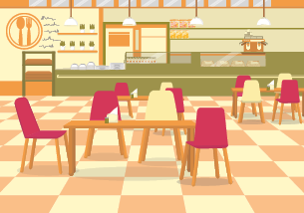 | 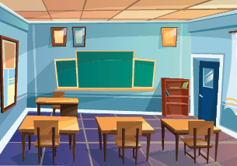
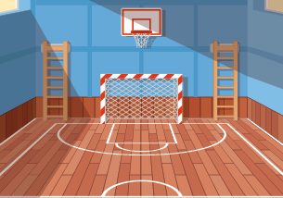 | 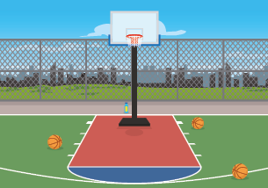
He isn’t in the classroom.
He isn’t in the sports field.
He isn’t in the gym.
So the impostor  is in the ____________________________________. Tricky hungry boy!!!
B. Read the sentences and look at the pictures. Which school event are these characters from the game Among Us going to participate in?

1
2
3
4
1. We go to a Valentine’s Day / Foam party! Love is in the air!
2. I’m wearing a Harry Potter costume for the Christmas / Carnival party.
3. The Halloween party / gaming tournament at school is always scary! I’m a pumpkin this year!
4. Ho! Ho! Ho! Don’t forget my present for the Christmas party / book fair.

