City places and activities (Unit 4)
Worksheet
7C6
Name No.: ______ Class: ________ Date: _____/ _____/ _____
A. Where is Johnny English going to strike again? Label the pictures with city places from the box.
airport | hotel | library | railway station | stadium | museum

 |  | 
1. | 2. | 3.
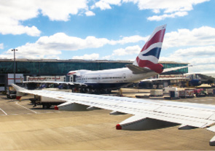 | 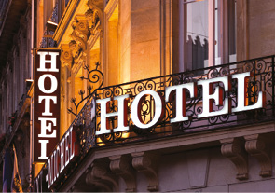 | 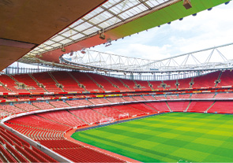
4. | 5. | 6.

B. Read the sentences and circle the correct option.

5. I love pets, especially dogs! That’s why I always
help people that eat ice cream / walk their dogs
in the city!
4. There are excelente
restaurants in London
that’s why I often
go to the theatre / eat out!
2. Imagine Dragons is my favourite
band. I always
walk along the street / go to a concert
by this band!
1. I go to the stadium /
go shopping to watch a
football match. Go, go
Manchester United!!
3. I go to the cinema /
go sightseeing to watch
a film. I love
James Bond films!

