Shops and city features (Unit 4)
Worksheet
8A6
Name No.: ______ Class: ________ Date: _____/ _____/ _____
A. Complete the sentences with the shops. Then match them with the pictures. Write numbers 1-6.
1. You can buy potatoes at the . | 4. You can buy bread at the .
2. You can buy books at the . | 5. You can buy a dress at the .
3. You can buy a football at the . | 6. You can buy magazines at the .

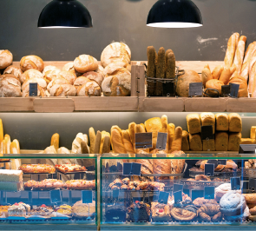 | 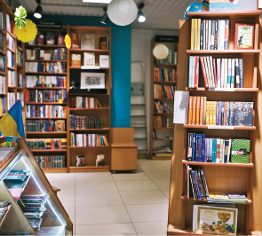 | 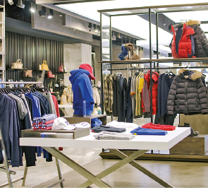
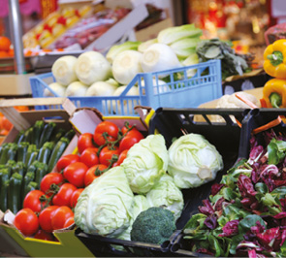 | 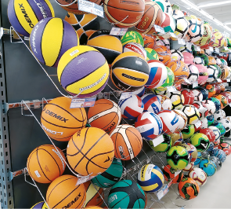 | 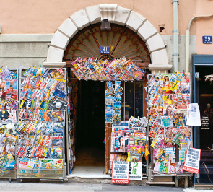
B. Complete the text with the city features from the box. There are three extra words/expressions.
zebra crossing | bridge |  | roundabout |  | traffic lights |  | tunnel
pavements |  | bus stops |  | crossroads |  | cycle lane

Hi, I’m Petra. I’m a policewoman and I love the town where
I work. There’s a 1____________________ that crosses a river and
the 2____________________ where people walk are all very
clean. People respect the road signs and cyclists only use
the 3____________________ to ride their bikes. Pedestrians,
cyclists and drivers always respect the 4____________________
and they never ignore a red light, especially next to a
5____________________ where people usually cross the
street. There are also many buses, so we have more than
one hundred 6____________________ in town.

