Shops and city features (Unit 4)
Worksheet
8B6
Name No.: ______ Class: ________ Date: _____/ _____/ _____
A. Write the names of the shops. The first and last letters are given.
s p
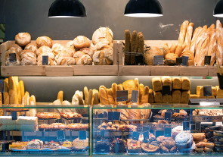 |  | 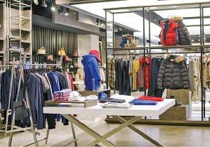
1.  b ’s | 2.  b p | 3. _______________  c p
 | 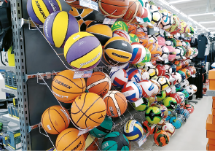 | 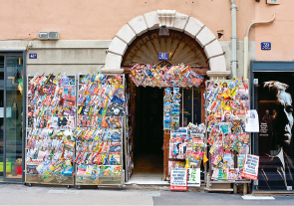
4.  g ’s | 5. _______________ | 6.  n ’s
B. Complete the sentences with the shops from exercise A.
1. You can buy a  at the . | 4. You can buy  at the .
2. You can buy  at the . | 5. You can buy  at the .
3. You can buy a  at the . | 6. You can buy  at the .
C. Complete the text with the missing words/expressions from the box. The pictures will help you.
zebra crossing | bridge | traffic lights | pavements | bus stops | cycle lane

Hi, I’m Petra. I’m a policewoman and I love my little town. There’s a
1_______________  that crosses a river and the 2_______________ 
where people walk are all very clean. People respect the road signs and
cyclists only use the 3_______________ 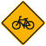 to ride their bikes.
Pedestrians, cyclists and drivers always respect the 4_______________ 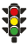
and they never ignore a red light, especially next to a 5_______________ 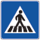
where people usually cross the street. There are also many buses, so we have
more than one hundred 6_______________  in town.

