Shops and city features (Unit 4)
Worksheet
8C6
Name No.: ______ Class: ________ Date: _____/ _____/ _____
A. Look at the pictures and tick (✓) the correct shop.
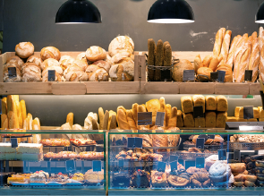  1 |   2 | 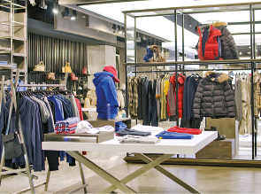  3
a) fishmonger’s  b) baker’s | a) greengrocer’s  b) bookshop | a) clothes shop  b) pet shop
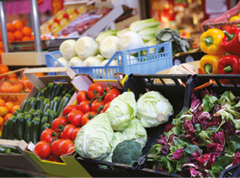  4 | 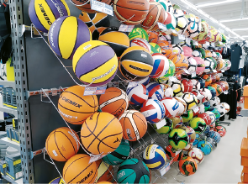  5 | 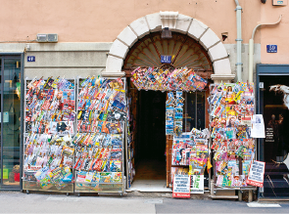  6
a) chemist’s  b) greengrocer’s | a) sports shop  b) computer shop | a) shoe shop  b) newsagent’s
B. Label the pictures with the words from the box.
zebra crossing | bridge | traffic lights | pavement | bus stop | cycle lane

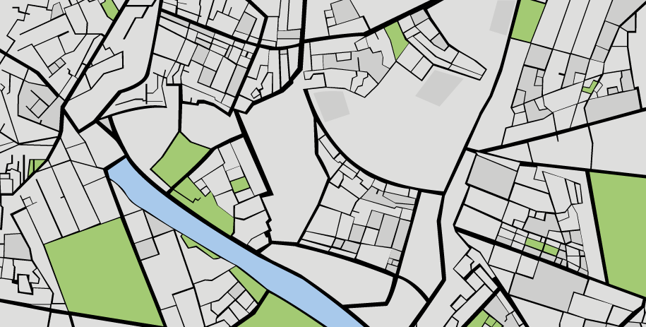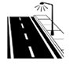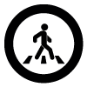
1
2
3
4
5
6
1.  2. | 3.  4. | 5.  6.

