Sports and free time activities (Unit 5)
Worksheet
9A6
Name No.: ______ Class: ________ Date: _____/ _____/ _____
A. Label with the names of the sports.
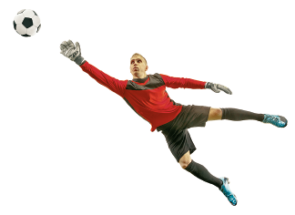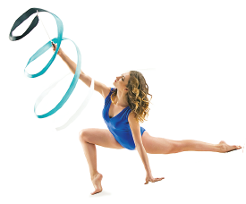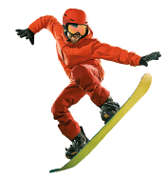
1
2
3
4
5
6
7
8
1. | 5.
2. | 6.
3. | 7.
4. | 8.
B. Check out some posters of films/series and complete the sentences with free time activities.
  1 |   2 |   3
  4 |   5 | 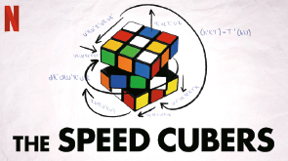  6
1. I love _____________________. Their routines are amazing!
2. __________________________ is the best to relax.
3. ______________________________ and __________________ the guitar are two of my favourites!
4. ______________________________ is definitely something I love!
5. ______________________________ with friends is lots of fun!
6. I enjoy ____________________ all kinds of _____________ to help me concentrate!

