Sports and free time activities (Unit 5)
Worksheet
9B6
Name No.: ______ Class: ________ Date: _____/ _____/ _____
A. Label with the sports from the box.
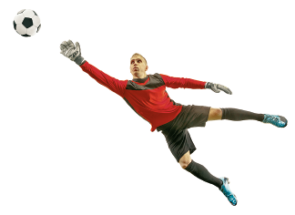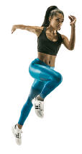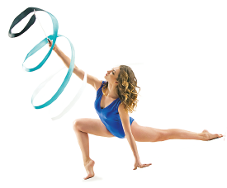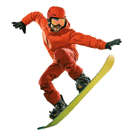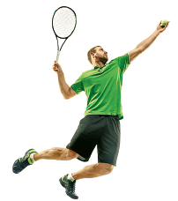
1
2
3
4
5
6
7
8
tennis | running | football | gymnastics | snowboarding | volleyball | rugby | basketball

1. | 5.
2. | 6.
3. | 7.
4. | 8.
B. Check out some posters of films/series and tick (✓) the correct sentence to label them.
1. a) Taking selfies is the best way to relax before competitions!  b) Playing video games is so much fun! | 
2. a) Drawing is definitely something I love!  b) Listening to music is definitely something I love! | 
3. a) I love dancing. Their routines are amazing!  b) I love riding a bike. Their routines are amazing! | 