Sports and free time activities (Unit 5)
Worksheet
9C6
Name No.: ______ Class: ________ Date: _____/ _____/ _____

A. Look at the pictures and circle the correct sport.
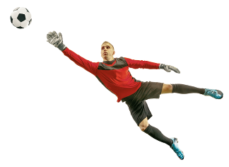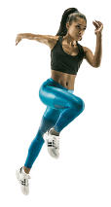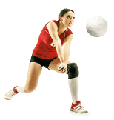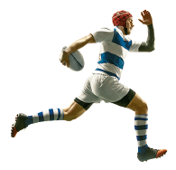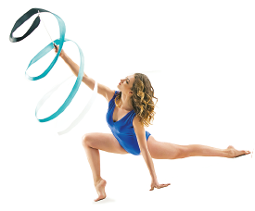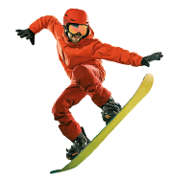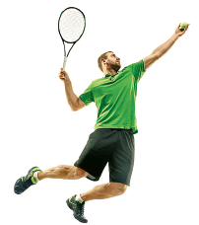
1
2
3
4
5
6
7
8
1. football / karate | 5. gymnastics / hockey
2. gymnastics / running | 6. snowboarding / basketball
3. baseball / volleyball | 7. volleyball / tennis
4. rugby / gymnastics | 8. hockey / basketball
B. Check out some posters of films/series and tick (✓) the correct option to label them.
1. a) Taking selfies | b) Playing video games | 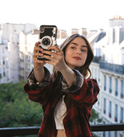
2. a) Drawing | b) Listening to music | 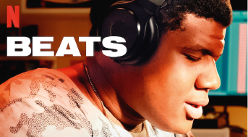
3. a) Dancing | b) Riding a bike | 