Unit 2
Writing Worksheet
2A6
Name No.: ______ Class: ________ Date: _____/ _____/ _____
A. Read the description below.
The house of my dreams
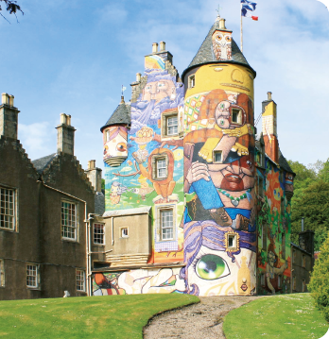
Kelburn Castle
(Scotland)

My dream house is similar to Kelburn Castle, in Scotland.
Imagine waking up in a royal bed with warm sunlight shining through your bedroom window. This is what I dream of when I imagine my ideal house.
It has got three floors with a total of six bedrooms, three bathrooms, a large kitchen, a living room and an attic.
The attic is my favourite spot because it’s where I do the things I like the most and spend some time on my own.
There is a secret forest full of mysteries and the exterior walls have got colourful paintings. Even the chimneys have got funny drawings!
B. Write a description with the title “The house of my dreams”.
Type of house and location:
– castle, detached house, flat, mansion,
cottage;
– countryside; city
Reason why it’s your ideal house:
– huge; cosy; comfortable
Floors and rooms in the house:
– number of floors;
– number/characteristics of the bedrooms;
bathrooms; living room; kitchen…
Favourite spot in the house/why:
– I have some privacy; I do/have the things I like there…
Other features that make the house special:
– garden, swimming pool…
Plan first
THE HOUSE OF MY DREAMS
My dream house is a
in the
It's my ideal house because
It has got
The is my favourite spot because
There is even

Remember
To use the verbs to be, have got and there to be. | To use different adjectives:  comfortable; big; huge; colourful; cosy; warm;  large; funny; ideal

