Unit 2
Writing Worksheet
2B6
Name No.: ______ Class: ________ Date: _____/ _____/ _____
A. Read the description below.
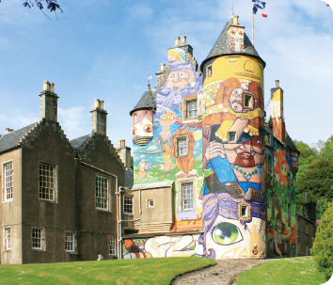
My dream house is a castle
Kelburn Castle
(Scotland)

My dream house is similar to Kelburn Castle, in Scotland.
It has got three floors with a total of six bedrooms, three bathrooms, a large kitchen, a living room and an attic.
The attic is my favourite spot.
There is a secret forest and the exterior walls have got colourful paintings. Even the chimneys have got funny drawings!
B. Write a description with the title “My dream house is a…”. Replace the underlined expressions from the description in A with your ideas, if necessary. You can use the vocabulary from the box to help you.
Type of house and location:
– castle, detached house, flat, mansion,
cottage;
– countryside; city
Floors and rooms in the house:
– number of floors;
– number/characteristics of the bedrooms; bathrooms; living room; kitchen…
Favourite spot in the house:
– attic; bedroom; study; living room;
garden…
Other features that make the house special:
– garden, swimming pool…
Plan first
MY DREAM HOUSE IS A
My dream house is a
in the
It has got
The is my favourite spot because
There is even

Remember
To use the verbs to be, have got and there to be. | To use different adjectives:  comfortable; big; huge; colourful; cosy; warm;  large; funny

