Unit 4
Writing Worksheet
4A6
Name No.: ______ Class: ________ Date: _____/ _____/ _____
A. The pictures below are from a story entitled “My most exciting visit to a place”. Pay attention to the sentences that match each picture as they tell you part of this story.
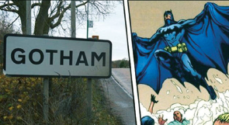  My parents, my sister and  I went to Gotham, a small  village in England, last  September. We knew we  couldn’t find Batman there,  but we wanted to visit the  place. | 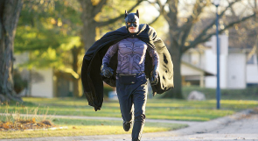  When we were driving  along the small roads of  Gotham, we saw a figure  of a man that looked like  Batman running in the  middle of the street. |   My father didn’t stop, but  we were quite surprised  to see that person there.  Who was he? We still have  no idea!
B. Write your own story with the title “An exciting visit to…”. You can imagine it (invent the name of a place/village/city or name a real one) and use real pictures or draw them yourself.
How you felt at the end – surprised;
anxious; happy, excited; sad…
Description of what happened
Plan first
Who – I; parents; siblings; friends…
Where – country; city; village of…
When – last…; in…; yesterday…
What – visit the place; meet new
people; go sightseeing; visit
museums/monuments…
An exciting visit to

Remember
To use the past simple and the past continuous when you write a story telling about past events.

