Unit 4
Writing Worksheet
4B6
Name No.: ______ Class: ________ Date: _____/ _____/ _____
A. The pictures below are from a story entitled “My most exciting visit to a place”. Pay attention to the sentences that match each picture as they tell you part of this story.
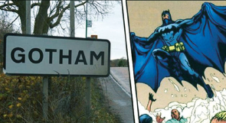  My parents, my sister and  I went to Gotham, a small  village in England, last  September. We knew we  couldn’t find Batman there,  but we wanted to visit the  place. | 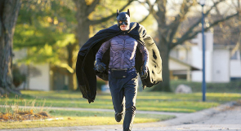  When we were driving  along the small roads of  Gotham, we saw a figure  of a man that looked like  Batman running in the  middle of the street. |   My father didn’t stop, but  we were quite surprised  to see that person there.  Who was he? We still have  no idea!
B. Write your own story with the title “Something to remember”. Use the prompts below the pictures to write your story.
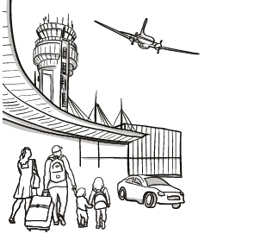  I / my parents / airport /  yesterday / go on a trip to  visit Hawaii | 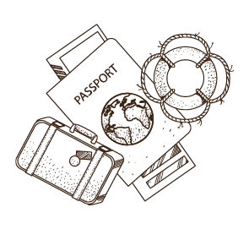  We / check in / forget /  passports at home | 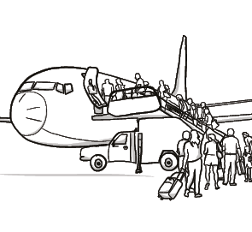  feel happy
(how you felt)
(description of what happened).
(what).
(where)
(when)
(who)
Something to remember
were
to
Suddenly, when
we realised
In the end my sister brought us the passports and we
because we could finally travel to Hawaii.

