Unit 5
Writing Worksheet
5A
Name No.: ______ Class: ________ Date: _____/ _____/ _____
A. Read the email Summer Camp #inAction sent answering Louise’s questions. Check the flyer of the Summer Camp they sent attached to the answer.
To: Summer Camp #inAction
Subject: Information

Dear Sirs,
Can you please give me more information on your summer camp?
How old are the participants? When will it take place? Which activities are we going to do there?
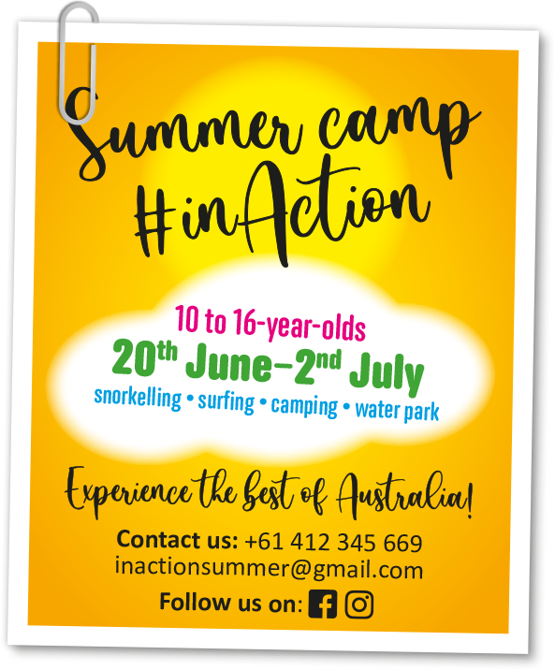
Best regards,
Louise Richards
RE: Information
To: Louise Richards

Dear Louise,
PARTICIPANTS
AGE
WHEN IT
WILL TAKE
PLACE
ACTIVITIES
We’re very excited to welcome you to Summer Camp
#inAction.
If you are between 10 and 16 years old you can come
to the camp. It will take place from 20th June to 2nd
July. You are going to try different activities such as
snorkelling and surfing. You are also going to camp
for three nights and swim in our water park every day.
Hope you come and experience adventure with us!
See you soon.
Samantha Peterson
(Camp counsellor)

B. Louise also sent the same email asking information to Summer Camp Summer Wonder. Look at the flyer of this summer camp and answer Louise’s questions as if you were the camp’s counsellor.
Remember
Dear Louise,
Thanks for writing us.
(Camp counsellor)

To use will or be going to to refer to future  events. | To greet and say goodbye when you write an  email.

