Unit 5
Writing Worksheet
5B
Name No.: ______ Class: ________ Date: _____/ _____/ _____
A. Read the email Louise sent to Summer Camp #inAction asking for information.
To: Summer Camp #inAction
Subject: Information

Dear Sirs,
Can you please give me more information on your summer camp?
How old are the participants? When will it take place? Which activities are we going to do there?
Best regards,
Louise Richards
B. Now check the flyer of the Summer Camp they sent attached to the answer to Louise.
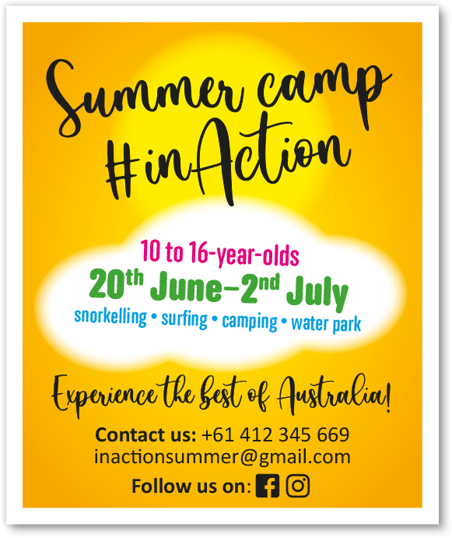
C. Complete the email sent by the camp counsellor to Louise. Use the information from the flyer in exercise B.
RE: Information
To: Louise Richards

Dear Louise,
We’re very excited to welcome you to Summer Camp ___________________ (camp’s name).
If you are between ___________________ (participants’ age) you can come to the camp. It will take
place from ___________________ (when it will take place). You are going to try different activities
such as ___________________ and ___________________. You are also going to go ___________________
for three nights and swim in our ___________________ every day (activities you can do there).
Hope you come and experience adventure with us!
See you soon.
Samantha Peterson
(Camp counsellor)

