Listening Test
Name No.: ______ Class: ________ Date: _____/ _____/ _____
Mark: ________________ Teacher: __________________________________ Enc. Educação: ______________________
2A6

A. Listen to the dialogue and put the pictures in order. Write 1-7. There is one extra picture.
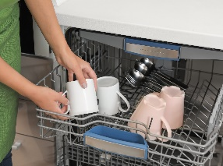

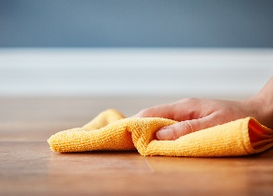


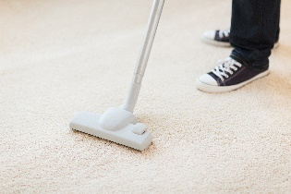
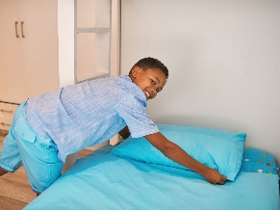

a)

b)
c)
d)

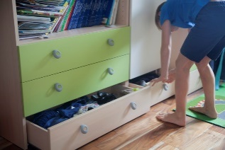

e)
f)
g)
h)

B. Listen to some teens talking about their houses. Read the sentences and tick (✔) the correct option.

1. Eva’s favourite place in her house is the __________________.
a) kitchen
b) living room
c) swimming pool
d) bedroom
2. There’s _____________________ in Nicks’s living room.
a) a microwave, an armchair and a toaster
b) a blender, a coffee table and an oven
c) a fireplace, a rug and cupboards
d) a coffee table, an armchair and a lamp
3. Darcy lives in ____________________.
a) a flat
b) a cottage
c) a detached house
d) a terraced house
4. The perfect spot for barbecues in Jake’s house is the _____________________.
a) living room
b) dining room
c) backyard
d) kitchen
Good work! 

Reading Test
Name No.: ______ Class: ________ Date: _____/ _____/ _____
Mark: ________________ Teacher: __________________________________ Enc. Educação: ______________________
2A6
Read the article.

The invisible treehouse
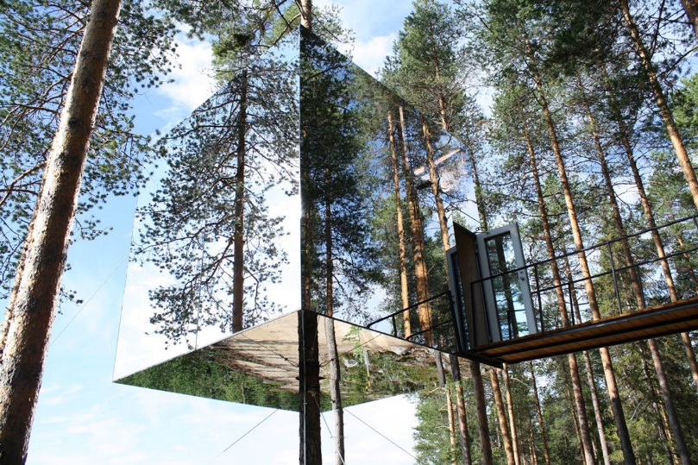
By Joey Sambora

Most people live in houses on the ground, but my house is… in the trees! It’s the mirrorcube treehouse, and it’s exactly what it sounds like – a giant box made of mirrors, hanging¹ in the middle of the forest. From the outside, it’s almost impossible to see because it reflects everything around it. Sometimes birds even fly right into it because they can’t tell it’s there!
To get inside, you have to go through a rope bridge², which is pretty cool. It seems you’re going into a secret place. The inside is small but cosy, with only three rooms: a bathroom, a kitchen and a bedroom. There are windows on every side, so you can see everything around you. One of the best parts is that no one can see you – and that’s AWESOME! Sometimes I just sit by the window and watch animals passing by. At night, the sky is full of stars and it’s completely quiet.
Living here is so peaceful… There are no neighbours, no streets, no cars – only the sound of nature. Sometimes I miss being around other people, but then I remember how special this place is. How many people can say they live in a treehouse that’s invisible? It’s like something out of a fairy tale.

5

10

15

Based on: www.travel+leisure.com; www.architecturaldigest.com
Vocabulary: ¹ hanging = pendurada; ² rope bridge = ponte de corda

A. Read the sentences and write T (true) or F (false).

1. The mirrorcube treehouse is located in the middle of a busy city.

2. Birds sometimes fly into the treehouse because they can’t see it.

3. The house is big and comfortable.

4. At night, you can only hear the neighbours.

B. Answer the questions about the article. Give complete answers.

1. Why is the treehouse almost invisible?
_____________________________________________________________________________
_____________________________________________________________________________

2. How do people get inside the house?
_____________________________________________________________________________
_____________________________________________________________________________

3. What is there inside the house?
_____________________________________________________________________________
_____________________________________________________________________________

4. Why is it so peaceful living there?
_____________________________________________________________________________
_____________________________________________________________________________

Good work!

Language Test
Name No.: ______ Class: ________ Date: _____/ _____/ _____
Mark: ________________ Teacher: __________________________________ Enc. Educação: ______________________
2A6

A. What are they doing? Look at the pictures and tick (✔) the correct option.
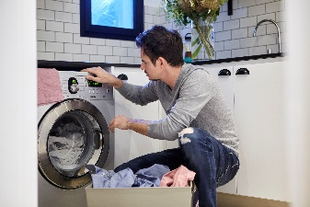
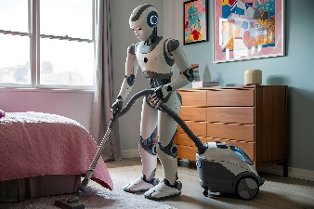
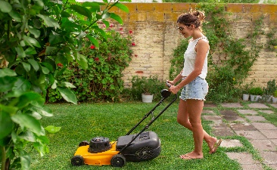
3
2
1

a) It is vacuuming the floor.
b) It is setting the table.
a) She is washing the car.
b) She is cutting the grass.
a) He is making the bed.
b) He is doing the laundry.

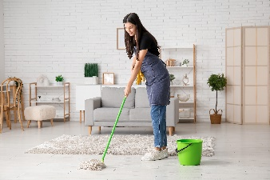
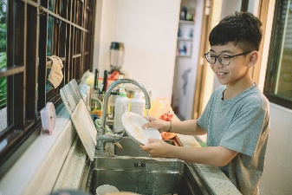
5
4

a) He is cooking. a) She is mopping the floor.
b) He is doing the dishes. b) She is taking the rubbish out.

B. Fill in the gaps with rooms of the house or furniture.



The treehouse is small and cosy. There’s a ¹ ____________ with a ² ___________ ,
a ³ __________________ , a toilet, a shower and a ⁴ ______________. Next to the bedroom, there’s a ⁵ ______________ with a ⁶ ______________  , a microwave, a ⁷___________  , a ⁸ ____________  and two cupboards.

C. Complete the sentences with the present continuous of the verbs in brackets.

1. Joey and his girlfriend __________________________ (prepare) dinner.

2. Joey __________________________ (not listen) to music.

3. ______________________________ (Joey / do) the laundry?
4. At the moment they __________________________ (not tidy) the bedroom.

D. Complete the text with the present simple or the present continuous of the verbs in brackets.

Joey and his girlfriend ¹ _________________ (do) the household chores today. They actually ²__________________ (tidy up) the bedroom first and then Joey ³ ________________ (mop) the floor. Now, they ⁴ _________________ (dust) the furniture and the girl ⁵ _________________ (fold) the laundry, too.
They often ⁶ ____________________ (cook) lunch and have all their meals together, but now they ⁷ _____________________ (not prepare) it because Joey’s girlfriend ⁸______________ (have) lunch with some friends.

E. Complete the sentences with the correct personal pronoun (object) from the box. There are two extra options.
them her you us it me

1. Joey’s house is cosy. He really likes ______________.

2. Joey and his girlfriend are enjoying the birds singing. They really love listening to ______________.

3. I’m talking to you. Can’t you hear ______________?
4. We live in an unusual treehouse in the forest. Our parents don’t visit ______________ very often.

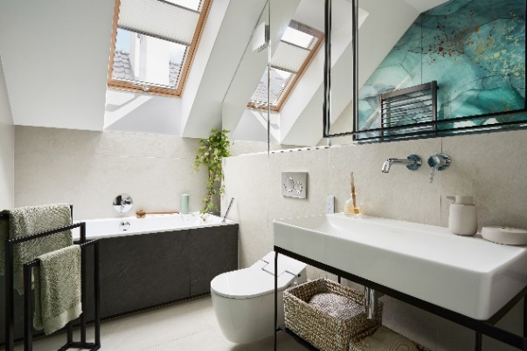
F. Look at the picture. Complete the sentences with under, opposite, between, next to, above.
Use each preposition only ONCE.

1. The towels are ______________ the washbasin.
2. The toilet is ______________ the bath.
3. The window is ______________ the bath.
4. The basket is ______________ the washbasin.
- The toilet is ______________ the bath and the basket.

G. Match the two halves to make new words. Write a-f.
Good work!

1. bed | - case
2. stair | - shelf
3. dish | - chair
4. book | - scraper
5. sky | - room
6. arm | - washer

Good work!

Writing Test
Name No.: ______ Class: ________ Date: _____/ _____/ _____
Mark: ________________ Teacher: __________________________________ Enc. Educação: ______________________
2A6

Imagine a completely unusual house where you would like to live.
This house could be in a strange location and have different characteristics.
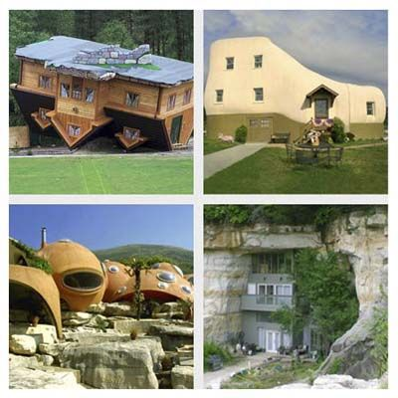
Describe it in 40-50 words.

Follow the guidelines below:
- location and type of house;
- rooms inside (upstairs/downstairs);
- your favourite room of the house and the furniture in it.

Don’t forget to give it a title!

___________________________________________________________________

___________________________________________________________________________________________________________________________________________________
___________________________________________________________________________________________________________________________________________________
___________________________________________________________________________________________________________________________________________________
___________________________________________________________________________________________________________________________________________________
___________________________________________________________________________________________________________________________________________________
___________________________________________________________________________________________________________________________________________________
___________________________________________________________________________________________________________________________________________________
___________________________________________________________________________________________________________________________________________________
___________________________________________________________________________________________________________________________________________________
___________________________________________________________________________________________________________________________________________________
___________________________________________________________________________________________________________________________________________________
___________________________________________________________________________________________________________________________________________________
___________________________________________________________________________________________________________________________________________________

Good work!

