Listening Test
Name No.: ______ Class: ________ Date: _____/ _____/ _____
Mark: ________________ Teacher: __________________________________ Enc. Educação: ______________________
2B

A. Listen to the dialogue and put the pictures in order. Write 1-7.

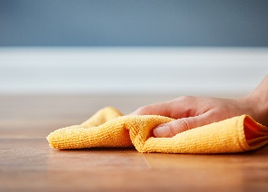
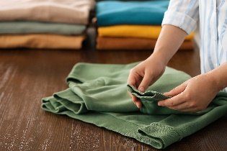
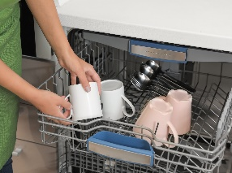

a)

d)

c)

b)

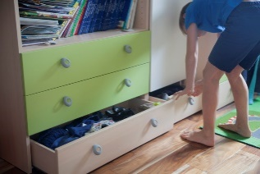
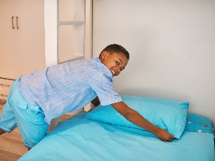
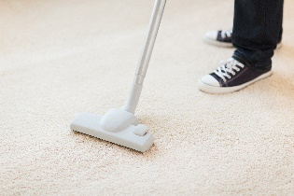

e)

g)

f)

B. Listen to some teens talking about their houses. Read the sentences and tick (✔) the correct option.

1. Eva’s favourite place in her house is the ______________________.
a) kitchen
b) living room
c) swimming pool

2. There’s _________________________ in Nicks’s living room.
a) a coffee table, an armchair and a lamp
b) a microwave, an armchair and a toaster
c) a fireplace, a rug and cupboards

3. Darcy lives in _______________________.
a) a flat
b) a cottage
c) a detached house

4. The perfect spot for barbecues in Jake’s house is the ____________________.
a) living room
b) dining room
c) backyard Good work! 

Reading Test
Name No.: ______ Class: ________ Date: _____/ _____/ _____
Mark: ________________ Teacher: __________________________________ Enc. Educação: ______________________
2B6

Read the article.

The invisible treehouse
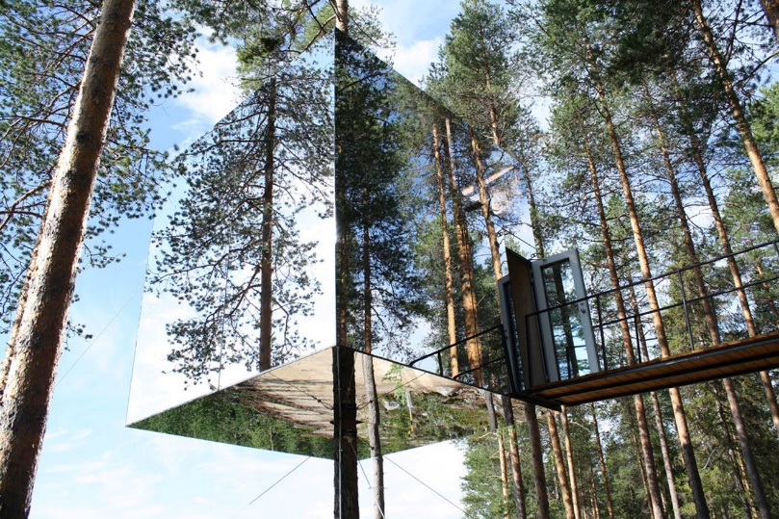
By Joey Sambora

Most people live in houses on the ground, but my house is… in the trees! It’s the mirrorcube treehouse, and it’s exactly what it sounds like – a giant box made of mirrors, hanging¹ in the middle of the forest. From the outside, it’s almost impossible to see because it reflects everything around it. Sometimes birds even fly right into it because they can’t tell it’s there!
To get inside, you have to go through a rope bridge², which is pretty cool. It seems you’re going into a secret place. The inside is small but cosy, with only three rooms: a bathroom, a kitchen and a bedroom. There are windows on every side, so you can see everything around you. One of the best parts is that no one can see you – and that’s AWESOME! Sometimes I just sit by the window and watch animals passing by. At night, the sky is full of stars and it’s completely quiet.
Living here is so peaceful… There are no neighbours, no streets, no cars – only the sound of nature. Sometimes I miss being around other people, but then I remember how special this place is. How many people can say they live in a treehouse that’s invisible? It’s like something out of a fairy tale.

5

10

15

Based on: www.travel+leisure.com; www.architecturaldigest.com
Vocabulary: ¹ hanging = pendurada; ² rope bridge = ponte de corda

A. Read the sentences and write T (true) or F (false).

1. The mirrorcube treehouse is in the middle of a city.

2. Birds sometimes fly into the treehouse because they can’t see it.

3. The house is big and comfortable.

4. At night, you can hear the neighbours.

B. Read the questions and complete the answers.

1. Why is the treehouse almost invisible?
The treehouse is almost invisible because it _________________________________________
_________________________.

2. How do people get inside the house?
People have to ___________________________________________ to get inside the house.

3. What is there inside the house?
There are _________________________ inside the house: a __________________________,
a _________________________ and a _________________________.

4. Why is it so peaceful living there?
It’s so peaceful living there because there aren’t any _________________________, streets or cars, only the ____________________________________.

Good work!

Language Test
Name No.: ______ Class: ________ Date: _____/ _____/ _____
Mark: ________________ Teacher: __________________________________ Enc. Educação: ______________________
2B6

A. What are they doing? Look at the pictures and tick (✔) the correct option.
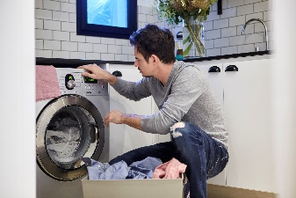
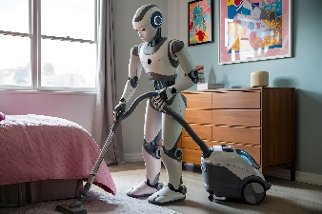
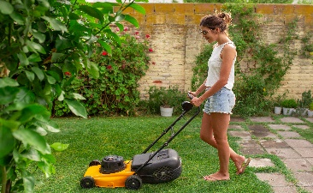
2
3
1

a) Vacuuming the floor
b) Setting the table
a) Washing the car
b) Cutting the grass
a) Making the bed
b) Doing the laundry

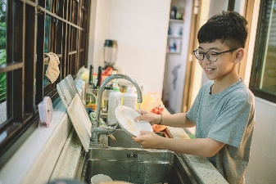
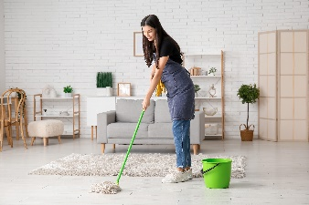
4
5

a) Cooking a) Mopping the floor
b) Doing the dishes b) Taking the rubbish out

B. Fill in the gaps with the missing vowels to write the rooms of the house and the furniture.
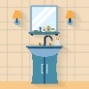
b t h r m
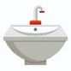

The treehouse is small and cosy. There’s a ¹ __ __ __ __ __ __ __ __ with a
w s h b s n
m r r r


² __ __ __ __ __ __ , a ³ __ __ __ __ __ __ __ __ __ , a toilet, a shower and a
k t c h n
c p b r d



⁴ __ __ __ __ __ __ __ __ . Next to the bedroom, there’s a ⁵ __ __ __ __ __ __ __
c k r
s n k
f r d g
with a ⁶ __ __ __ __ __ __ , a microwave, a ⁷ __ __ __ __ , a ⁸ __ __ __ __ __ __
and two cupboards.

C. Tick (✔) the correct present continuous form to complete the sentences.

- Joey and his girlfriend ____________________ dinner.

a) are preparing b) is preparing

- Joey _____________________ to music.

a) aren’t listening b) isn’t listening

- _______________________ the laundry?

a) Is joey doing b) Am Joey doing

4. At the moment they _____________________ the bedroom.

a) isn’t tidying b) aren’t tidying


D. Circle the correct forms of the verbs.

Joey and his girlfriend ¹ are doing / is doing the household chores today. They actually
² tidies up / tidy up the bedroom first and then Joey ³ mops / are mopping the floor. Now, they ⁴ dust / are dusting the furniture and the girl ⁵ am folding / is folding the laundry, too.
They often ⁶ cook / cooks lunch and have all their meals together, but now they
⁷ aren’t preparing / isn’t preparing it because Joey’s girlfriend ⁸ has / is having lunch with some friends.

E. Complete the sentences with the correct personal pronoun (object) from the box. There is one example.
them him us it me

him
• Joey sings so well. Listen to _____________.

1. Joey’s house is cosy. He really likes ______________.

2. Joey and his girlfriend are enjoying the birds singing. They really love listening to ______________.

3. I’m talking to you. Can’t you hear ______________?
4. We live in an unusual treehouse in the forest. Our parents don’t visit ______________ very often.

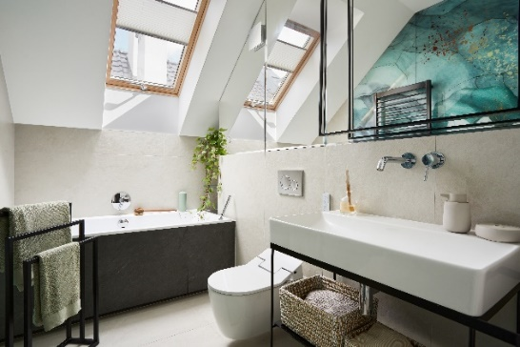
F. Look at the picture and circle the correct prepositions.

1. The towels are above / opposite the washbasin.
2. The toilet is next to / in the bath.
3. The window is behind / above the bath.
4. The basket is under / in front of the washbasin.
5. The toilet is between / in the bath and the basket.

G. Match the two halves and write new words. There is one example.
1. sky | - case
2. bed  d) | - shelf
3. stair | - chair
4. dish | - scraper
5. book | - room
6. arm | - washer

Good work!

Writing Test
Name No.: ______ Class: ________ Date: _____/ _____/ _____
Mark: ________________ Teacher: __________________________________ Enc. Educação: ______________________
2B6

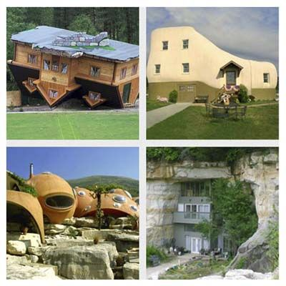
Imagine a completely unusual house where you would like to live.
This house could be in a strange location.
Describe it in 40-50 words.

Follow the guidelines below:
- location and type of house;
- number of floors, rooms inside;
- your favourite room of the house and its furniture.

Look at the example:
type of house
location
rooms inside
The upside-down house is a mansion in the forest.
It has got one floor. There is a bedroom, a bathroom, a kitchen and a study.
My favourite spot is the bedroom. There’s a big bed, an orange armchair and posters.

furniture
favourite spot

The _________________ is a _________________ in _________________________
_____________________________________________________________________
_____________________________________________________________________
_____________________________________________________________________
_____________________________________________________________________
_____________________________________________________________________
_____________________________________________________________________

Good work!

