Name |  | No. | Class
Date | Mark | Teacher

Look at the photos and make sentences using the present simple or present continuous.
Follow the example.
A
usually / pick up plastic | 1. now / read a book
They usually pick up plastic.
2. every day / play the drums | 3. sometimes / play video games
4. Listen! / sing | 5. help / kitchen / at the moment

Look at Jen’s diary and make sentences in the present simple or present continuous. Follow the example.
On Mondays, Jen often cleans her room but now she is doing her homework.
B
Monday | (often) clean  room | (now) do  homework
Tuesday | (always)  study | (at the moment)  watch TV | 1.
Wednesday | (never) go to  the gym | (today) go to the gym | 2.
Friday | (rarely) go  shopping | (this afternoon)  buy a present | 3.
At weekends | (usually)  visit her  grandparents | (tomorrow)  have a birthday  party | 4.
Complete the sentences with the verbs in brackets using the present simple or the present continuous.
C
1. Wendy usually (go) to the cinema with her friends.
2. What mum __________________ (do) at the moment?
She __________________ (prepare) dinner.
3. Every morning I __________________ (brush) my teeth after breakfast.
4. You __________________ (not study) at the weekend.
5. Look Tim, that drone __________________ (fly) over your house!
6. My sister and I __________________ (volunteer) at the Food Bank twice a year.
7. Paul __________________ (not visit) his brother this week, he __________________ (work).
8. Where __________________ Angela __________________ (live)?
She __________________ (live) in Vancouver.
9. __________________ Thomas ________________________ (cut) the grass now?
No, he __________________. He ____________________ (paint) the walls.

Name |  | No. | Class
Date | Mark | Teacher

Choose the correct option to complete the sentences in the present simple or in the present continuous. Follow the example.
A
They usually _____________ plastic.  a. pick up b. are picking up  sdfsdfsdfsdfasdfasdfasdfasdfasdfsdfvaaaaaaggghhnnn  sdfsdfsdfsdfasdfasdfasdfasdfasdfsdfvaaaaaaggghhnnn | 1. Now he _____________ a book.  a. reads b. is reading  sdfsdfsdfsdfasdfasdfasdfasdfasdfsdfvaaaaaaggghhnnn  sdfsdfsdfsdfasdfasdfasdfasdfasdfsdfvaaaaaaggghhnnn
2. She _____________ the drums every day.  a. plays b. is playing  sdfsdfsdfsdfasdfasdfasdfasdfasdfsdfvaaaaaaggghhnnn  sdfsdfsdfsdfasdfasdfasdfasdfasdfsdfvaaaaaaggghhnnn | 3. They sometimes ________ video games.  a. play b. is playing  sdfsdfsdfsdfasdfasdfasdfasdfasdfsdfvaaaaaaggghhnnn  sdfsdfsdfsdfasdfasdfasdfasdfasdfsdfvaaaaaaggghhnnn
4. Listen! She _______________________.  a. sings b. is singing  sdfsdfsdfsdfasdfasdfasdfasdfasdfsdfvaaaaaaggghhnnn  sdfsdfsdfsdfasdfasdfasdfasdfasdfsdfvaaaaaaggghhnnn | 5. We __________ in the kitchen at the moment.  a. help b. are helping  sdfsdfsdfsdfasdfasdfasdfasdfasdfsdfvaaaaaaggghhnnn  sdfsdfsdfsdfasdfasdfasdfasdfasdfsdfvaaaaaaggghhnnn

Look at Jen’s diary and make sentences in the present simple or present continuous. Follow the example.
On Mondays, Jen often cleans her room but now she is doing her homework.
B
Monday | (often) clean  room | (now) do  homework
Tuesday | (always)  study | (at the moment)  watch TV | 1. On Tuesdays, Jen ,  but at the moment she  .
Wednesday | (never) go to  the gym | (today) go to the gym | 2. On Wednesdays, Jen ,  but today she  .
Friday | (rarely) go  shopping | (this afternoon)  buy a present | 3. On Fridays, Jen ,  but this afternoon she  .
At weekends | (usually)  visit her  grandparents | (tomorrow)  have a birthday  party | 4. At weekends, Jen ,  but tomorrow she  .
Circle the correct option to make sentences in the present simple or present continuous.
C
1. Wendy usually goes / is going to the cinema with her friends.
2. What does mum do / is mum doing at the moment?
She prepares / is preparing dinner.
3. Every morning I brush / am brushing my teeth after breakfast.
4. You don’t study / aren’t studying at the weekend.
5. Look Tim! That drone flies / is flying over your house.
6. My sister and I volunteer / are volunteering at the Food Bank twice a year.
7. Paul doesn’t visit / isn’t visiting his brother this week, he works / is working.
8. Where does Angela live / is Angela living?
She lives / is living in Vancouver.
9. Does Thomas cut / Is Thomas cutting the grass now?
No, he doesn’t / isn’t. He paints / is painting the walls.

Name |  | No. | Class
Date | Mark | Teacher

Use the pictures to form words.
A
1. | 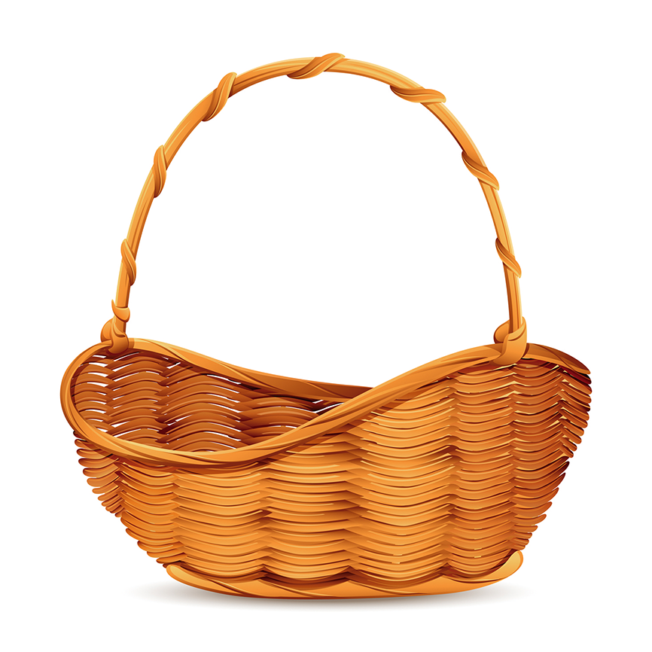 | + |  | = | ______________ |  | 4. | 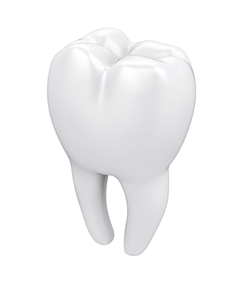 | + | 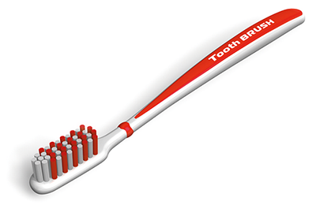 | = | ______________
2. |  | + |  | = | ______________ |  | 5. |  | + |  | = | ______________
3. |  | + | 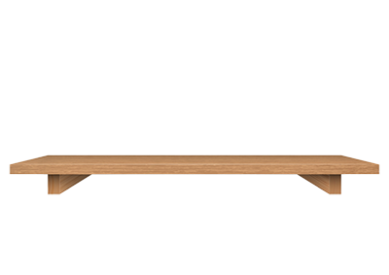 | = | ______________ |  | 6. |  | + | 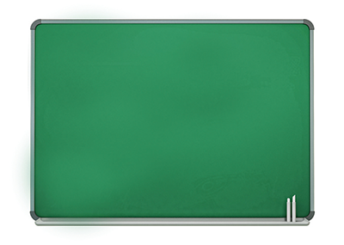 | = | ______________
Match the words with the prefixes to form new words. Then write the words.
B
ir | 1 | • |  | • | a | kind __________________
im | 2 | • |  | • | b | legal __________________
in | 3 | • |  | • | c | regular __________________
il | 4 | • |  | • | d | correct __________________
un | 5 | • |  | • | e | possible __________________
un | 6 | • |  | • | f | patient __________________
ir | 7 | • |  | • | g | complete __________________
in | 8 | • |  | • | h | happy __________________
in | 9 | • |  | • | i | logical __________________
il | 10 | • |  | • | j | responsible __________________
Match the words with the suffixes to form new words. Then write the words.
C
accept | 1 | • |  | • | a | ly __________________
quiet | 2 | • |  | • | b | ful __________________
teach | 3 | • |  | • | c | able __________________
care | 4 | • |  | • | d | er __________________
paint | 5 | • |  | • | e | ly __________________
comfort | 6 | • |  | • | f | ful __________________
wonder | 7 | • |  | • | g | able __________________
quick | 8 | • |  | • | h | er __________________

Name |  | No. | Class
Date | Mark | Teacher

Use the pictures to form words.
A
1. |  | + |  | = | b __ __ __ __ __ b __ __ __ |  | 4. |  | + |  | = | t __ __ __ __ b __ __ __ __
2. |  | + |  | = | n __ __ __ p __ __ __ __ |  | 5. |  | + |  | = | s __ __ g __ __ __ __ __ __
3. |  | + |  | = | b __ __ __ s __ __ __ __ |  | 6. |  | + |  | = | c __ __ b __ __ __ __
Choose the correct prefix to form new words. Then write the words.
B
1. in / ir regular __________________
2. im / ir possible __________________
3. un / in correct __________________
4. im / il legal __________________
5. il / un kind __________________
6. in / un happy __________________
7. im / ir responsible __________________
8. in / im complete __________________
9. im / il patient __________________
10. un / il logical __________________
Choose the correct suffix to form new words. Then write the words.
C
1. accept able / er __________________
2. quiet ful / ly __________________
3. teach er / ful __________________
4. care ful / ly __________________
5. paint ly / er __________________
6. comfort ful / able __________________
7. wonder er / ful __________________
8. quick able / ly __________________

