Name |  | No. | Class
Date | Mark | Teacher

Choose the correct option.
A
1. Janet ____________________ photos when the boat passed under the bridge.
a. | sdfsdfsdfsdfasdfasdfasdfasdfasdfsdfvaaaaaaggghhnnn | took | b. | sdfsdfsdfsdfasdfasdfasdfasdfasdfsdfvaaaaaaggghhnnn | was taking | c. | sdfsdfsdfsdfasdfasdfasdfasdfasdfsdfvaaaaaaggghhnnn | take
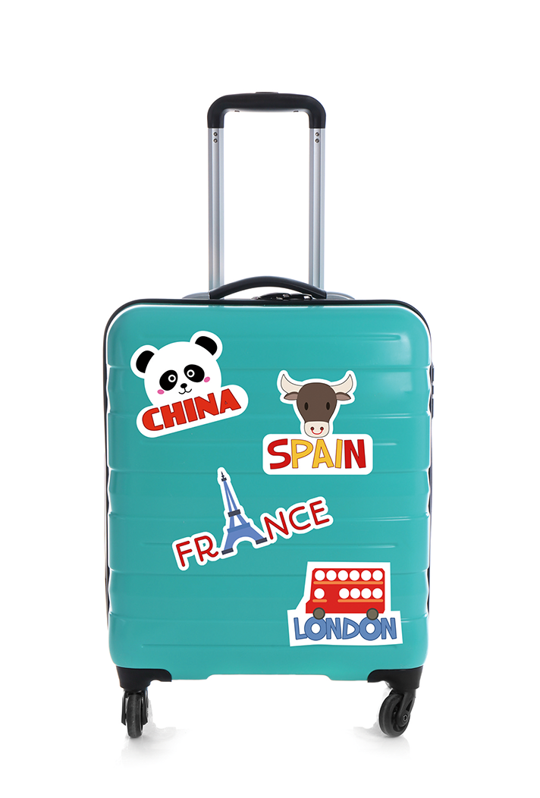
2. When the tourists ____________________ to the hotel, it was raining.
a. | sdfsdfsdfsdfasdfasdfasdfasdfasdfsdfvaaaaaaggghhnnn | arrived | b. | sdfsdfsdfsdfasdfasdfasdfasdfasdfsdfvaaaaaaggghhnnn | were | c. | sdfsdfsdfsdfasdfasdfasdfasdfasdfsdfvaaaaaaggghhnnn | arriving
3. Greg and Andy ____________________ the art exhibition while we were having coffee.
a. | sdfsdfsdfsdfasdfasdfasdfasdfasdfsdfvaaaaaaggghhnnn | admired | b. | sdfsdfsdfsdfasdfasdfasdfasdfasdfsdfvaaaaaaggghhnnn | were admiring | c. | sdfsdfsdfsdfasdfasdfasdfasdfasdfsdfvaaaaaaggghhnnn | admire
4. The children ____________________ their suitcases yesterday at that time.
a. | sdfsdfsdfsdfasdfasdfasdfasdfasdfsdfvaaaaaaggghhnnn | didn’t pack | b. | sdfsdfsdfsdfasdfasdfasdfasdfasdfsdfvaaaaaaggghhnnn | weren’t packing | c. | sdfsdfsdfsdfasdfasdfasdfasdfasdfsdfvaaaaaaggghhnnn | pack
5. We____________________ our flight when we heard about the tropical storm.
a. | sdfsdfsdfsdfasdfasdfasdfasdfasdfsdfvaaaaaaggghhnnn | cancelled | b. | sdfsdfsdfsdfasdfasdfasdfasdfasdfsdfvaaaaaaggghhnnn | were cancelling | c. | sdfsdfsdfsdfasdfasdfasdfasdfasdfsdfvaaaaaaggghhnnn | cancel
6. When Fabio ____________________ in Spain, he saw his best friend Rodrigo there.
a. | sdfsdfsdfsdfasdfasdfasdfasdfasdfsdfvaaaaaaggghhnnn | was | b. | sdfsdfsdfsdfasdfasdfasdfasdfasdfsdfvaaaaaaggghhnnn | was being | c. | sdfsdfsdfsdfasdfasdfasdfasdfasdfsdfvaaaaaaggghhnnn | be
7. Kevin ____________________ to Dublin last week.
a. | sdfsdfsdfsdfasdfasdfasdfasdfasdfsdfvaaaaaaggghhnnn | didn’t travel | b. | sdfsdfsdfsdfasdfasdfasdfasdfasdfsdfvaaaaaaggghhnnn | wasn’t travelling | c. | sdfsdfsdfsdfasdfasdfasdfasdfasdfsdfvaaaaaaggghhnnn | travel
8. What time ____________________ the museum ____________________ yesterday?
a. | sdfsdfsdfsdfasdfasdfasdfasdfasdfsdfvaaaaaaggghhnnn | did / open | b. | sdfsdfsdfsdfasdfasdfasdfasdfasdfsdfvaaaaaaggghhnnn | was / opening | c. | sdfsdfsdfsdfasdfasdfasdfasdfasdfsdfvaaaaaaggghhnnn | does / open
9. The tigers ____________________ when we arrived to the zoo.
a. | sdfsdfsdfsdfasdfasdfasdfasdfasdfsdfvaaaaaaggghhnnn | ate | b. | sdfsdfsdfsdfasdfasdfasdfasdfasdfsdfvaaaaaaggghhnnn | were eating | c. | sdfsdfsdfsdfasdfasdfasdfasdfasdfsdfvaaaaaaggghhnnn | eat
Fill in the gaps with the verbs in brackets. Use the past simple or past continuous.
B
1. I ____________________ (get) the suitcases out of the car while my wife ______________________ (talk)
to the receptionist.
2. When Jeremy ____________________ (go) to Dublin, he ____________________ (visit) his sister.
3. I ____________________ (buy) a fridge magnet at a souvenir shop last summer.
4. It ____________________ (not snow) when the plane ____________________ (land).
5. Yesterday at 7 o’clock the guards ____________________ (march) in front of Buckingham Palace.
6. What ____________________ Layla ____________________ (do) last weekend?
7. Where _______________________ you ______________________ (go) when I ______________________ (call) you?
8. Many people ______________________________ (watch) the penguins in the aquarium while others ____________________ (take) photos of the bears in the Zoo.

Name |  | No. | Class
Date | Mark | Teacher

Choose the correct option.
A
1. Janet _____________________ photos when the boat passed under the bridge.
a. | sdfsdfsdfsdfasdfasdfasdfasdfasdfsdfvaaaaaaggghhnnn | took | b. | sdfsdfsdfsdfasdfasdfasdfasdfasdfsdfvaaaaaaggghhnnn | was taking
2. When the tourists _____________________ to the hotel, it was raining.
a. | sdfsdfsdfsdfasdfasdfasdfasdfasdfsdfvaaaaaaggghhnnn | arrived | b. | sdfsdfsdfsdfasdfasdfasdfasdfasdfsdfvaaaaaaggghhnnn | arriving
3. Greg and Andy _____________________ the art exhibition while we were having coffee.
a. | sdfsdfsdfsdfasdfasdfasdfasdfasdfsdfvaaaaaaggghhnnn | admired | b. | sdfsdfsdfsdfasdfasdfasdfasdfasdfsdfvaaaaaaggghhnnn | were admiring
4. The children _____________________ their suitcases yesterday at that time.
a. | sdfsdfsdfsdfasdfasdfasdfasdfasdfsdfvaaaaaaggghhnnn | didn’t pack | b. | sdfsdfsdfsdfasdfasdfasdfasdfasdfsdfvaaaaaaggghhnnn | weren’t packing
5. We _____________________ our flight when we heard about the tropical storm.
a. | sdfsdfsdfsdfasdfasdfasdfasdfasdfsdfvaaaaaaggghhnnn | cancelled | b. | sdfsdfsdfsdfasdfasdfasdfasdfasdfsdfvaaaaaaggghhnnn | were cancelling
6. When Fabio _____________________ in Spain, he saw his best friend Rodrigo there.
a. | sdfsdfsdfsdfasdfasdfasdfasdfasdfsdfvaaaaaaggghhnnn | was | b. | sdfsdfsdfsdfasdfasdfasdfasdfasdfsdfvaaaaaaggghhnnn | was being
7. Kevin _____________________ to Dublin last week.
a. | sdfsdfsdfsdfasdfasdfasdfasdfasdfsdfvaaaaaaggghhnnn | didn’t travel | b. | sdfsdfsdfsdfasdfasdfasdfasdfasdfsdfvaaaaaaggghhnnn | wasn’t travelling
8. What time _____________________ the museum _____________________ yesterday?
a. | sdfsdfsdfsdfasdfasdfasdfasdfasdfsdfvaaaaaaggghhnnn | did / open | b. | sdfsdfsdfsdfasdfasdfasdfasdfasdfsdfvaaaaaaggghhnnn | was / opening
9. The tigers _____________________ when we arrived to the zoo.
a. | sdfsdfsdfsdfasdfasdfasdfasdfasdfsdfvaaaaaaggghhnnn | ate | b. | sdfsdfsdfsdfasdfasdfasdfasdfasdfsdfvaaaaaaggghhnnn | were eating
Circle the correct option.
B
1. I got / was getting the suitcases out of the car while my wife talked / was talking to the receptionist.
2. When Jeremy went / was going to Dublin, he visited / was visiting his sister.
3. I bought / was buying a fridge magnet at a souvenir shop last summer.
4. It didn’t snow / wasn’t snowing when the plane landed / was landing.
5. Yesterday at 7 o’clock the guards marched / were marching in front of Buckingham Palace.
6. What did Layla do / was Layla doing last weekend?
7. Where did you go / were you going when I called / was calling you?
8. Many people watched / were watching the penguins in the aquarium while others
took / were taking photos of the bears in the Zoo.

Name |  | No. | Class
Date | Mark | Teacher

Match the columns to make sentences.
A
Grace really loves museums; |  | • |  | • |  | however, we decided  to visit Paris this summer.
Grace really loves museums; | 1 | • |  | • | a | however, we decided  to visit Paris this summer.
The souvenir shop  is closed today, |  | • |  | • |  | therefore, they’re going  to Buckingham Palace today.
The souvenir shop  is closed today, | 2 | • |  | • | b | therefore, they’re going  to Buckingham Palace today.
We love going to London  every year; |  | • |  | • |  | so we went on foot  to Piccadilly Circus.
We love going to London  every year; | 3 | • |  | • | c | so we went on foot  to Piccadilly Circus.
My grandparents want  to see the Queen; |  | • |  | • |  | therefore, she is visiting Madame  Tussauds wax museum next week.
My grandparents want  to see the Queen; | 4 | • |  | • | d
We were tired of waiting  for the bus, |  | • |  | • |  | so I’m going to come back tomorrow.
We were tired of waiting  for the bus, | 5 | • |  | • | e | so I’m going to come back tomorrow.
Complete the sentences with: however, so, therefore.
B
1. There are many black taxis in London; ______________, it’s easy
to get around.
2. I really enjoy trying new food; ________________, I didn’t like the
fish and chips.
3. Margaret wanted to buy her sister a present, __________________ she
went to the gift shop.
4. I wanted to go on the London Eye; _________________, it was closed.
5. The students didn’t have tickets for the show, _________________ they didn’t go.
6. It’s a beautiful sunny day; _________________, many people are going to St James’s Park.
Ask and answer questions. Follow the example.
C
It’s raining again. Alexandra is taking her umbrella. (so)
It’s raining again, so Alexandra is taking her umbrella.

1. Judy and Mike love London. They are going to Japan this year. (however)

2. You didn’t do well on your exams. You aren’t going to the Harry Potter show. (so)

3. Agatha wasn’t feeling well. She didn’t visit the History Museum. (therefore)

4. Football is our favourite sport. We didn’t visit Wembley Stadium. (however)

Name |  | No. | Class
Date | Mark | Teacher

Match the columns to make sentences.
A
Grace really loves museums; |  | • |  | • |  | however, we decided  to visit Paris this summer.
Grace really loves museums; | 1 | • |  | • | a | however, we decided  to visit Paris this summer.
The souvenir shop  is closed today, |  | • |  | • |  | therefore, they’re going  to Buckingham Palace today.
The souvenir shop  is closed today, | 2 | • |  | • | b | therefore, they’re going  to Buckingham Palace today.
We love going to London  every year; |  | • |  | • |  | so we went on foot  to Piccadilly Circus.
We love going to London  every year; | 3 | • |  | • | c | so we went on foot  to Piccadilly Circus.
My grandparents want  to see the Queen; |  | • |  | • |  | therefore, she is visiting Madame  Tussauds wax museum next week.
My grandparents want  to see the Queen; | 4 | • |  | • | d
We were tired of waiting  for the bus, |  | • |  | • |  | so I’m going to come back tomorrow.
We were tired of waiting  for the bus, | 5 | • |  | • | e | so I’m going to come back tomorrow.
Complete the sentences with: however, so, therefore.
B
1. There are many black taxis in London; therefore, / however, it’s
easy to get around.
2. I really enjoy trying new food; however, / therefore, I didn’t like
the fish and chips.
3. Margaret wanted to buy her sister a present, therefore / so she went
to the gift shop.
4. I wanted to go on the London Eye; so, / however, it was closed.
5. The students didn’t have tickets for the show, so / however they didn’t go.
6. It’s a beautiful sunny day; therefore, / however, many people are going to St James’s Park.
Link the sentences using the words in brackets. Follow the example.
C
It’s raining again. Alexandra is taking her umbrella. (so)
It’s raining again, so Alexandra is taking her umbrella.
1. Judy and Mike love London. They are going to Japan this year. (however)
Judy and Mike
2. You didn’t do well on your exams. You aren’t going to the Harry Potter show. (so)
You didn’t do well
3. Agatha wasn’t feeling well. She didn’t visit the History Museum. (therefore)
Agatha wasn’t feeling
4. Football is our favourite sport. We didn’t visit Wembley Stadium. (however)
Football is our

