
UNIT 3b English test (A)

NAME: Nr. CLASS:
DATE: EVALUATION:
TEACHER: E. E.

I
Listening /10

1 Listen to the dialogue. Answer the questions.

1) Is Danni late?

2) What are Danni and James talking about?

3) What is their relationship?

4) What does Danni give to James?
II
Reading /10

Danni’s Dream House
My dream house meets student Danni, 15. She designs houses and furniture on her computer at home.
I use a computer program to design houses — just for fun! This is my dream house: I’ve got a big house next to the sea. It’s not real, but I like imagining I live there. My house has got five bedrooms. I imagine some crazy parties with my friends in the house.
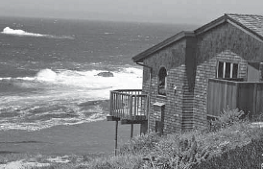The living room’s cool. The windows are big; there’s a fantastic view of the beach. Everything in the room’s pink or white. There’s a pink carpet, and on the wall there’s a great sound system. Next to the window there are shelves with books on them. I haven’t got any more furniture or any plants.

5) Are they in a park?

6) Does Danni describe the train station?

2 Listen again. True or false?

1) There is a good café.

True False

2) The café is on the right.

True False

3) The café is opposite the computer shop.

True False

4) The clothes shop is next to bank.

True False

5) The fast food restaurant is next to the internet café.

True False

1 Read the text. True or false? Correct the false sentences.

1) Danni uses a computer game.

2) Danni is a designer.

3) Danni is at school.

4) Danni designs houses for fun.

5) It’s a real house.

2 Read again. Answer the questions.
6

1) Is there a carpet in her living room?

2) What type of things does Danni imagine in her house?

3) Are there any blue things in the living room?

4) Where is the sound system?

5) Where are the shelves?
2 Order the letters of the words in the box.
Then complete the sentences.

fsleh | rorirm | tapln | mstsye snuod adwrrebo | oilplw

1) You sleep with your head on a .

2) A ’s got leaves. It’s green.

3) You play music with a .

4) You put clothes in a .

5) You look in a .

IV
Grammar /30

1 Order the words to make sentences.

III
Vocabulary /20

1 Label the pictures. 1) is / squares / star / the / between / the

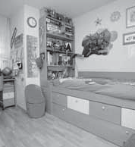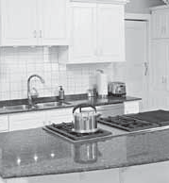1 2

2) the / above / square / the / is / star

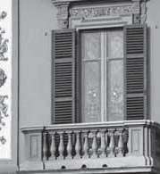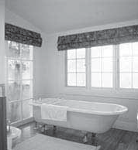3 4

3) to the / is / next / star / square / the

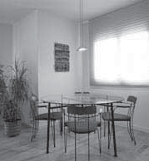5 4) the / star / behind / the / square / is

5) the / under / star / is / the / square

2 Complete the sentences with the object pronouns in the box.

it | us | them | it | her

1) I like cheese. I like .

2) I eat potatoes and tomatoes every day.

I eat every day.

3) Do you like my dog? Do you like

?

4) They never talk to you and me. They never talk to .
5) I sometimes visit my grandmother.

I sometimes visit .

3 Order the words to make questions.

1) Charles / has / blond / got / hair ?

2) door / house / your / has / got / a / red ?
Writing /20

1 Circle the correct option.
V

My perfect room

1) The walls are pink/pinks.

2) There is a TV big/big TV on the wall.

3) It’s got a lot of windows rounds/round windows.

4) There’s/ There are a beautiful bed next to the window.

5) The mirror new/new mirror is behind the door.

2 Describe your perfect home.

Paragraph 1: Is it big? Small? What colour(s) is it?
Paragraph 2: How many bedrooms are there? Are there other rooms?
Paragraph 3: What furniture have you got in your living room? Where is it?

My perfect home is

3) Sally / have / and / brother / Ruby / got / a ?

It’s got

4) dog / you / have / a / got ?

5) fridge / her / Kylie / in / milk / any / got /
has ?

4 Complete the answers with have, haven’t,
has or hasn’t.

1) No, he . It’s brown.

2) No, it . It’s got a blue door.

3) Yes, they . They gave it to me.

4) Yes, I . It’s a Labrador. It likes to play with its ball.

5) No, she . She needs some more.

My living room has got

Speaking /10
TOTAL /100

6 UNIT 3b English test (B)

NAME: Nr. CLASS:
DATE: EVALUATION:
TEACHER: E. E.

I
Listening /10

1 Listen to the dialogue. Answer the questions.

1) Who is late?

2) How and why is Danni helping James?

3) Where are they exactly?

4) Are they old friends?
II
Reading /30

Danni’s Dream House
My dream house meets Danni, 15, from Newport in Wales. In her free time she designs houses and furniture on her computer at home. She wants to be a professional designer.
I use a computer program to design houses – just for fun! This is my dream house: I have a big house next to the sea. It’s not real, but I like imagining I live there. My house has got five bedrooms. I imagine all my friends staying in the house and we have some crazy parties.
The living room’s cool. The windows are big; there’s a fantastic view of the beach. Everything in the room’s pink or white. There’s a pink carpet, and on the wall there’s a great sound system. Next to the window there are shelves with books on them. I don’t have any more furniture or any plants in the room.

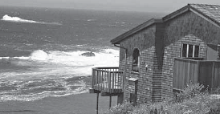5) What does Danni give to James?

2 Listen again. True or false? Correct the false sentences.

1) There’s a good café.

2) The café’s on the right.

1 Read the text. True or false? Correct the false sentences.

1) Newport’s in England.

3) The café’s opposite the computer shop.

2) Danni’s a teenager.

4) The clothes shop’s next to bank.

3) Danni’s got a real house next to the sea.

5) The fast food restaurant’s next to the internet café.

4) Danni’s a professional designer.

5) Danni’s got a disco with a sound system.

2 Read again. Answer the questions.

1) Is there a carpet in her living room?

2) What can you do with the computer program?

3) Where is Danni’s dream house?

4) What type of things does Danni imagine doing in her house?

5) Are there any blue things in the living room?
2 Order the letters of the words in the box.
Then complete the sentences.
6

fsleh | rorirm | tapln | mstsye snuod adwrrebo | oilplw

1) You sleep with your head on a .

2) A ’s got leaves. It’s green.

3) You play music with a .

4) You put clothes in a .

5) You look in a .

IV
Grammar /30

1 Where is the star? Describe the pictures.

III
Vocabulary /10

1 Label the pictures. 1)

1 2

2)

3 4
3)

4)

5

5)

2 Complete the sentences with an object pronoun, e. g. him, us, …
6

1) I like cheese. I like .

2) I eat potatoes and tomatoes every day.

I eat every day.

3) Do you like my dog? Do you like

?

4) They never talk to you and me. They never talk to .
5) I sometimes visit my grandmother.

I sometimes visit .

3 Order the words to make questions.

1) Charles / has / blond / got / hair ?

2) door / house / your / has / got / a / red ?
V
Writing /20

1 Circle the correct option.

My perfect room

1) The walls are pink/pinks.

2) There is a TV big/big TV on the wall.

3) It’s got a lot of windows rounds/round windows.

4) There’s/ There are a beautiful bed next to the window.

5) The mirror new/new mirror is behind the door.

2 Describe your perfect home.

Paragraph 1: Is it big? Small? What colour(s) is it?
Paragraph 2: How many bedrooms are there? Are there other rooms?
Paragraph 3: What furniture have you got in your living room? Where is it?

3) Sally / have / and / brother / Ruby / got / a ?

4) dog / you / have / a / got ?

5) fridge / her / Kylie / in / milk / any / got /has ?

4 Complete the answers.

1) No, he . It’s brown.

2) No, it . It’s got a blue door.

3) Yes, they . They gave it to me.

4) Yes, I . It’s a Labrador.
It likes to play with its ball.

5) No, she . She needs some more.

Speaking /10
TOTAL /100

