UNIT 1b

NAME: Nr. CLASS:
DATE: EVALUATION:
TEACHER: E. E.

REINFORCEMENT

Vocabulary

Family
- Find six words related to family.

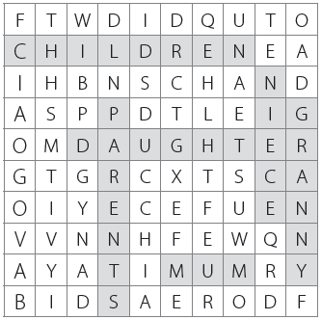

Adjectives for pets
4 Write the words.

1) My sister’s cat is very . (naelc)

2) I like rabbits. they are . (ddlyuc)

3) My dog is . (lyfriend)

4) My mother thinks spiders are . (caysr)

5) our bird is never quiet. It’s very . (oinsy)

6) I don’t like ants because they are

. (onnaying)

5 Match the people with the pets.

1 A

2 Circle the odd word.

1) mum | mother | son 2 B

2) grandfather | dad | grandad

3) stepfather | granny | grandmother
3 C
4) dad | nephew | father

5) aunt | uncle | cousins
6) niece | nephew | parents 4 D

3 Complete the next word in the puzzle.
1) daughter — mother — 5 E

gr

2) son — father — 6 F

gra

3) aunt — niece — uncle — nep

4) mother — stepfather — father —

stepm

5) mother — daughter — father — s

6) dad — father — mum —

mo
1) John’s pet is scary.

2) Granny’s pet is cuddly.

3) Katie’s pet is messy.

4) Dad’s pet is intelligent.

5) Grandad’s pet is clean.

6) My pet is quiet.

Grammar

this, that, these, those
1 Circle the correct option.

1 4

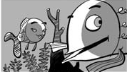2 5

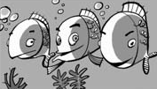3 6

1) This/That is my dad, Max.

2) This/That ’s Delia.

3) This/These are my best friends.

4) That/This is my games console.

5) These/Those are my computer games.

6) These/Those are my books.

Possessive adjectives/pronouns
2 Complete the sentences and then match them with the correct possessive pronoun.

1) I’m a fish. name’s nemo.

2) I’ve got a sister. name’s nora.

3) I’ve also got a brother. name’s nimo.

4) We live in the ocean. house is cool.

5) We’ve got a pet ant. name’s Pant.

6) We’ve got a lot of cousins. actors in animated films.

a) Its

b) mine c) hers d) their e) ours
f) his

Possessive ’s
3 Complete one gap in every sentence with
’s or ’.

Pop star Madonna’s got a big family. She’s got two sons and a daughter.

1) Madonna is my mum favourite singer and I like her too.

2) Madonna’ daughter is lourdes.

3) Her sons names are rocco and
David.

4) Lourdes dad lives in new York.

5) Madonna’s brothers names are
Martin, anthony and Christopher.

6) Her sisters names are Melanie and Paula Mae.

Whose ...?
4 Order the words to make questions.

1) pets / Whose / are these?

2) brothers / are alec and Daniel?/ Whose

3) school / Whose / is this?

4) Whose / are tiago and Gonçalo / children?

5) is Maria / Whose / mother?

Present simple
5 Write the sentences.
1) Bambi / swim every day. ✓

2) Bambi / play with cats. ✗

3) The actress / give Bambi chocolate. ✗

4) Bambi / stay at home every day. ✗

5) Bambi / have got an MP3 player. ✓

