UNIT 2a

NAME: Nr. CLASS:
DATE: EVALUATION:
TEACHER: E. E.

REINFORCEMENT

Vocabulary

Daily routines
1 Write the words in the correct category.
Free time activities
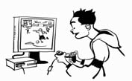4 Look at the pictures. Correct the text about Paul’s day.

1 4

to bed | a shower | lunch to school | breakfast | home

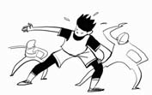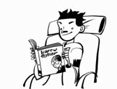Go Have 2 5

2 Order the words in brackets to make sentences.

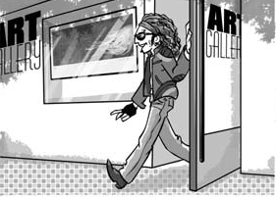

1) Steve up at 11 a.m. (keswa)

2) He has in bed. (fastreakb)

3) then he his teeth. (reshebus)

4) He goes to at 1.30. (loosch)

5) He has a . (ershow)

6) He has in a hotel. (nchlu)

3 Complete the sentences.

1) Billy ge at 12 o’clock.

2) He h di er in a restaurant.

3) He g ho e at 9.30 p.m.

4) He do some exercise at home.

5) Billy h a sho .

6) He go to b at 11.00.
3 6

1) Paul sees books.
2) He chats on the computer games.
3) He listens to friends.
4) He plays shopping.
5) He does music.
6) He reads on the Internet.

1)

2)

3)

4)

5)

6)

5 Circle the correct option.

1) I always do/listen exercise.

2) At the weekend I chat/listen on the Internet.

3) In the afternoon I do/see my friends.

4) We normally go/read shopping.

5) I usually read/play computer games in the evening.

6) I sometimes read/meet books.

Grammar

Adverbs of frequency
1 Order the words to make sentences.

3 Complete the questions.

do | where | what | does where | when



1) Juanes / in the shower / always sings

2) he / at the weekend / often plays / football

3) never sings / he / rap music

4) he / around the world / often travels

5) on the Internet / hardly ever chats / he

6) his friend Sally / usually meets / he
1) Fernando, do you live?
I live in Colombia. Sally and John are from the UK.

2) What you like reading?
I like reading Harry Potter books.

3) do you go to school?
I go to school every day, from Monday to Friday.

4) do you meet your friends?
I meet them at our football club.

5) Where your best friend live?
He lives next door.

6) does he do at the weekend?
He listens to music at my house.

love, like, not like, hate + -ing form
1 Write true (t) or false (f) about you.
Then correct the false sentences.

1) I love listening to rap music.

Present simple: questions
2 Complete the questions with do or does. Match the questions with the answers.
1) Sally, you listen to music?

2) you like John?

3) your boyfriend like John?

4) your mother like your music?

5) your fans chat with you on Internet?

6) your sister speak english?

a) Yes, they do.

b) no, he doesn’t!

c) Yes, I do.

d) Yes, she does.

e) Yes, I do.

f) Yes, she does.

2) I hate watching action films.

3) I hate doing exercise.

4) I don’t like shopping.

5) I love dancing.

6) I like swimming.

