
UNIT 3a

NAME: Nr. CLASS:
DATE: EVALUATION:
TEACHER: E. E.

REINFORCEMENT

Vocabulary

The weather
1 Complete the sentences.

Celebrity weather report:



1) In Miami it is h . It’s 40°C. J-Lo is on the beach.

2) But in New York it’s rai .
Leo de Caprio is in a cool restaurant.

3) In Tokyo it’s fo . We can’t see celebrities!

4) In Paris it’s 0°C. It’s co . Angelina has a winter jacket from Gucci.

5) In Colorado it’s sno .
It’s celebrity ski week. Penelope and Javier are here.

6) Finally, in London it’s clo .
Coldplay are at the airport. They’re going on holiday!

2 Circle the correct option.

1) In Sydney it’s summer. It’s sunny/snowing.
Nicola’s drinking ice tea.

2) The weather is great. It’s 25°C and it’s cold/warm.

3) In Hawaii it’s windy/raining. It’s a perfect day to surf. Welcome to celebrity surf!

4) The sky in Hollywood is grey, not blue! It’s a cloudy/warm day for the Oscars.
5) Don’t forget your raincoat at the Milan
Fashion Week because it’s raining/foggy.

6) It’s winter in Moscow. It’s -20 °C and it’s hot/cold. Enrique and Anna are shopping.

Collocations
3 Find the collocations.

- heiasreadanewspaperjsuwaksoelwn

- getawoalaeqreatsomecerealkatwusiw

- ihveadeamthaelttlwhbaldrinkmilkqo

- bauerobabankbaakoamaithpreideofu

- goisaoslebitimthrenothwathwatchtvi

- paawaarllinstowhelistentomusicanieo

4 Correct the collocations.

1) do the phone do

2) listen to a newspaper listen to

3) rob your homework rob

4) watch music watch

5) answer milk answer

6) eat a bank eat

7) drink some cereal drink

8) read TV read

5 Complete the sentences.

doing | reading | listening | watching answering | drinking

1) Enrique’s to music.

2) Nicole’s the phone.

3) Britney and Cristina are their homework.

4) Justin’s a newspaper.

5) Jennifer’s TV.

6) Leonardo’s milk.

Grammar

Present continuous
1 Circle the correct option

1) I’m lieing/lying on the sofa at the moment.

2) My mum is sitting/siting beside me.

3) We’re waching/watching the television.

4) My sister is phoning/phoneing her boyfriend.

5) My brother is swimming/swiming at the pool.

6) Dad is droving/driving home.

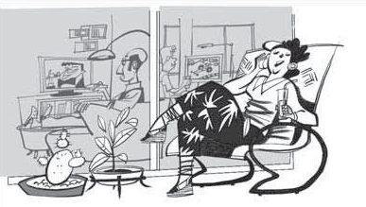2 Write true (t) or false (f). Correct the false sentences.

1

3 Complete the questions. Match the questions with the answers.

are | is | what | are | where | are

1) What you doing now?

2) you eating hamburgers?

3) your cousin with you?

4) are you going tomorrow?

5) are you buying?

6) you taking a lot of photographs?
a) We’re going shopping on Fifth Avenue.
b) Yes, she is.
c) I’m buying a new MP3 player.
d) Yes, I am.
e) We’re having lunch now.
f) No, we’re not. We’re having a salad and fries.

2

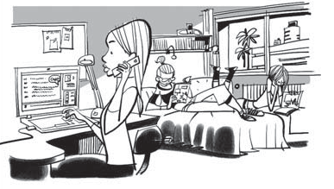1) ‘Hi Kelly. I’m cooking at the moment.’

2) ‘Dad is watching TV.’
Present continuous vs. Present simple
4 Circle the correct option.

1) I sing every day/at the moment because I
want to be a famous singer.

2) On Mondays/At the moment I’m studying for a music test.

3) I have a group. We’re doing a concert
next week/always.

4) My boyfriend sometimes/today plays the guitar with us.

5) We are writing a new song now/on
Saturdays.

6) We usually/tomorrow listen to music in my house.

3) ‘Your brother is doing his homework.’

4) ‘Hi Mum. I’m doing my homework.’

5) ‘No, Mum. We’re not shopping.’

6) ‘My friend isn’t listening to music, Mum.’

